**IS-455: Database Design and Prototyping**

**Report**

**MCKINLEY HEALTHCARE DATABASE SYSTEM**

**Table of Contents**

|  |  |  |
| --- | --- | --- |
| **Sr no.** | **Topic** | **Page no.** |
| **1** | Introduction | **3** |
| **2** | Components of Database Design   * Relationship and Cardinality | **4**  5 |
| **3** | Entity Relationship Diagram | **6** |
| **4** | Relational Model | **9** |
| **5** | Integrity Constraints | **10** |
| **6** | Normalization | **11** |
| **7** | SQL Queries   * Create Tables * Populate Tables * SQL Queries * SQL Views | **15**  15  17  22  30 |
| **8** | Security Access Management | **32** |

**I. Introduction**

Our project centers on revolutionizing the management of healthcare records within the McKinley Healthcare System through the development of a comprehensive database system. This system aims to streamline administrative tasks, enhance patient care delivery, and ensure efficient coordination across various aspects of healthcare management.

At the core of our project lies the goal of creating a centralized platform that facilitates the seamless organization and retrieval of essential healthcare data. By leveraging modern database technologies, we seek to optimize the management of patient information, prescription details, medical histories, appointments, and more.

Through careful design and implementation, our database system addresses the diverse needs of healthcare management within the McKinley Healthcare System. It provides a user-friendly interface for healthcare professionals to input, access, and analyze critical patient data, enabling informed decision-making and personalized care delivery.

Key functionalities of our database system include:

- **Patient Management:** Comprehensive storage of patient information, including demographics, contact details, insurance information, and emergency contacts.

- **Prescription Tracking:** Efficient management of medication prescriptions, dosage information, prescription dates, and associated appointments.

- **Appointment Scheduling:** Streamlined scheduling and management of patient appointments, ensuring timely access to healthcare services.

- **Medical History Maintenance:** Accurate recording and tracking of patients' medical conditions, diagnosis dates, treatment plans, and laboratory screening results.

- **Billing and Financial Management:** Seamless tracking of financial transactions, including bill generation, payment statuses, and insurance details.

- **Healthcare Provider Information:** Centralized storage of nurse and doctor details, including contact information, specializations, and department affiliations.

By implementing this database system, the McKinley Healthcare System aims to enhance operational efficiency, improve patient care outcomes, and foster greater collaboration among healthcare professionals. Through continuous refinement and optimization, our project seeks to contribute to the advancement of healthcare management practices within the organization.

**II. Components of Database Design**

To effectively design a database, we need to have a clear understanding of the entity sets and the relationships of entity sets stored in a database. An entity in this context is an object, a component of data. An entity set is a collection of similar entities. These entities can have attributes that define its properties.

In this project, a database management system for a Healthcare management system is made.

The entities and their respective attributes required are as follows:

1)Patient: Stores comprehensive information about patients including their demographics, contact details, medical history, and insurance details.

Attributes:

* Patient_ID (Primary Key): 1
* Name: John Doe
* Date of Birth (DOB): 1990-05-15
* Gender: Male
* Contact Number: 123-456-7890
* Address: 123 Main St, Anytown, USA
* Email: john.doe@example.com
* Insurance Details: XYZ Insurance, Policy #12345
* Emergency Contact (Foreign Key): 1 (Reference to Emergency Contact ID)

2)Prescription: Manages details of medication prescriptions including medication name, dosage, frequency, and associated appointments for patients.

Attributes:

* Prescription ID (Primary Key): 1
* Net ID (Foreign Key): N001
* Medication Name: Aspirin
* Dosage: 100mg
* Frequency: Once daily
* Prescription Date: 2024-04-20
* Expiration Date: 2024-05-20
* Appointment (Foreign Key): 1

3)Emergency Contact: Records emergency contact details for patients, including names, relationships, and contact numbers.

Attributes:

* Contact ID (Primary Key): 1
* Net ID (Foreign Key): 1
* Name: Jane Doe
* Relationship: Spouse
* Contact Number: +1234567890

4)Bills: Tracks financial transactions related to patient care, including bill IDs, total amounts, and payment statuses.

Attributes:

* Bill ID (Primary Key): 1
* Net ID (Foreign Key): 1
* Total Amount: $100.00
* Payment Status: Paid

5)McKinley Health Kits: Manages information about health kits provided to patients, including kit types, dates taken, and quantities taken

Attributes:

* Health Kit ID (Primary Key): 1
* Net ID (Foreign Key): 1
* Health Kit Type: First Aid Kit
* Date Taken: 2024-04-15
* Quantity Taken

6)Insurance:Stores details of patient insurance coverage, including insurance provider information, policy numbers, and coverage details

Attributes:

* Insurance ID (Primary Key): 1
* Net ID (Foreign Key): 1
* Insurance Provider: HealthCare Inc.
* Policy Number: HC123456
* Coverage Details: Full coverage

7)Medical History: Records patients' medical conditions, diagnosis dates, and treatment plans for reference and continuity of care.

Attributes:

* History ID (Primary Key): 1
* Net ID (Foreign Key): 1
* Medical Condition: Hypertension
* Diagnosis Date: 2020-01-01
* Treatment Plan: Prescribed medication and regular checkups

8)Appointment: Manages scheduling and status of patient appointments with healthcare providers.

Attributes:

* Appointment ID (Primary Key): 1
* Net ID (Foreign Key): 1
* Doctor ID (Foreign Key): 1
* Appointment Date: 2024-04-20 10:00:00
* Appointment Type: Follow-up
* Appointment Status: Scheduled

9)Lab Screening: Tracks laboratory screenings undergone by patients, including test names, dates, and results.

Attributes:

* Screening ID (Primary Key): 1
* Net ID (Foreign Key): 1
* Test Name: Blood Pressure
* Test Date: 2024-04-10
* Test Result: Normal

10)Department: Organizes healthcare departments within the system, including department names and locations.

Attributes:

* Department ID (Primary Key): 1
* Department Name: Cardiology
* Location: Main Building, 1st Floor

11)Nurse:Stores information about nurses working within the healthcare system, including their names, contact numbers, and email addresses.

Attributes:

* Nurse ID (Primary Key): 1
* Department ID (Foreign Key): 1
* Name: Sarah Johnson
* Contact Number: 111-111-1111
* Email: [sarah.johnson@example.com](mailto:sarah.johnson@example.com)

12)Doctor:Manages details of doctors working within the healthcare system, including their names, specializations, and contact information.

Attributes:

* Doctor ID (Primary Key): 1
* Department ID (Foreign Key): 1
* Name: Dr. Emily Carter
* Specialization: Cardiologist
* Contact Number: 333-333-3333
* Email: emily.carter@example.com

**RELATIONSHIP AND CARDINALITY**

1. Patient - Prescription Relationship:

- Relationship: Receives

- Cardinality: One-to-Many

- Explanation: Patients receive prescriptions from healthcare providers for medications. Each patient can receive multiple prescriptions over time, but each prescription is uniquely issued to one patient.

2. Patient - Emergency Contact Relationship:

- Relationship: Has

- Cardinality: One-to-Many

- Explanation: Patients designate emergency contacts for critical situations. Each patient can have multiple emergency contacts, but each emergency contact is associated with one patient.

3. Patient - Bills Relationship:

- Relationship: Incurs

- Cardinality: One-to-Many

- Explanation: Patients incur bills for healthcare services received. Each patient may incur multiple bills, but each bill is incurred by one patient.

4. Patient - McKinley Health Kits Relationship:

- Relationship: Uses

- Cardinality: One-to-Many

- Explanation: Patients utilize health kits for medical purposes. Each patient may use multiple health kits, but each health kit is assigned to one patient.

5. Patient - Insurance Relationship:

- Relationship: Has

- Cardinality: One-to-One

- Explanation: Patients have insurance coverage for healthcare needs. Each patient has one insurance policy, and each insurance policy belongs to one patient.

6. Patient - Medical History Relationship:

- Relationship: Has

- Cardinality: One-to-Many

- Explanation: Patients have medical histories documenting past conditions and treatments. Each patient may have multiple medical history records, but each record belongs to one patient.

7. Patient - Appointment Relationship:

- Relationship: Schedules

- Cardinality: One-to-Many

- Explanation: Patients schedule appointments for medical consultations. Each patient can schedule multiple appointments, but each appointment is scheduled by one patient.

8. Patient - Lab Screening Relationship:

- Relationship: Undergoes

- Cardinality: One-to-Many

- Explanation: Patients undergo lab screenings for diagnostic purposes. Each patient may undergo multiple lab screenings, but each screening is undergone by one patient.

9. Department - Nurse Relationship:

- Relationship: Manages

- Cardinality: One-to-Many

- Explanation: Departments manage nurses for staffing. Each department may manage multiple nurses, but each nurse is managed by one department.

10. Department - Doctor Relationship:

- Relationship: Employs

- Cardinality: One-to-Many

- Explanation: Departments employ doctors for medical care provision. Each department may employ multiple doctors, but each doctor is employed by one department.

11)Appointment - Doctor Relationship:

- Relationship: Assigns

- Cardinality: One-to-Many

- Explanation: Appointments are assigned to doctors for medical consultations. Each appointment is assigned to one doctor, but each doctor may have multiple appointments scheduled.

**III. Entity Relationship Diagram**

Entity relationship diagrams serve as graphical representations of the relationships between entities in a database, facilitating the conceptualization and planning of database structures. By visually illustrating the connections between various data entities, ER diagrams help stakeholders understand the database's architecture and requirements more effectively.

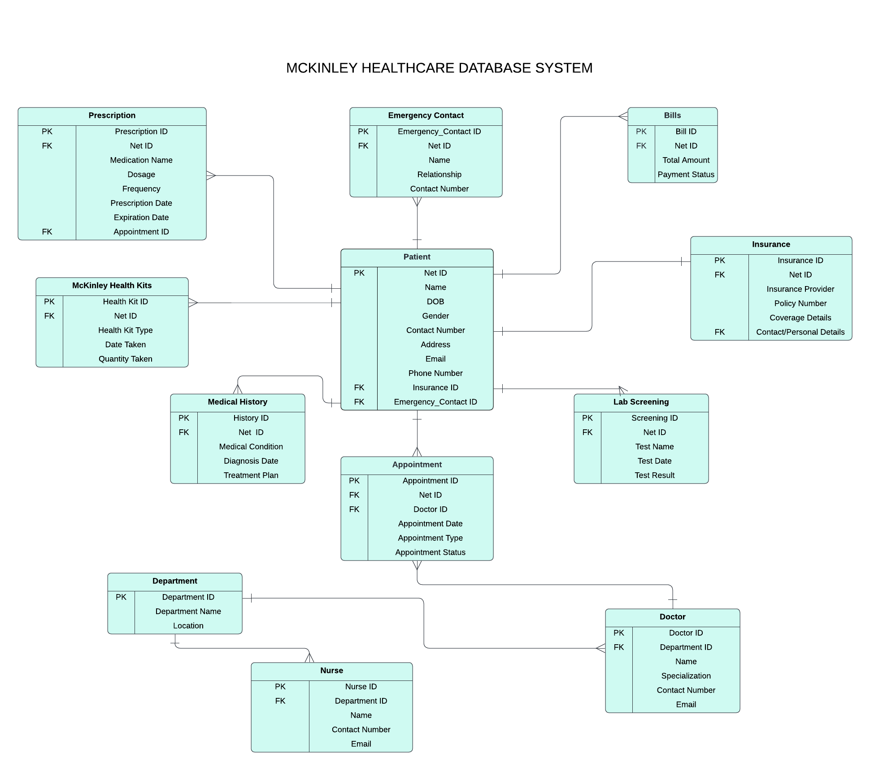

Arranging the ERD in a coherent manner is crucial for enhancing understanding. Entity-relationship diagrams serve the primary function of representing complex databases, making it essential to master the creation of straightforward, logical ERDs. ER diagrams are highly valuable tools, and the subsequent basic steps are essential for crafting one:

Determining the entities:

* McKinley Health Kits
* Patient
* Insurance
* Medical History
* Appointment
* Lab Screening
* Department
* Nurse
* Doctor

Determining the primary key for each entity:

* McKinley Health Kits: Health_Kit_ID (PK)
* Patient: Net_ID (PK)
* Insurance: Insurance_ID (PK)
* Medical History: History_ID (PK)
* Appointment: Appointment_ID (PK)
* Lab Screening: Screening_ID (PK)
* Department: Department_ID (PK)
* Nurse: Nurse_ID (PK)
* Doctor: Doctor_ID (PK)

Next, we need to determine the foreign key for the entities:

* Patient: Emp_ID (FK)
* Insurance: Net_ID (FK)
* Medical History: Net_ID (FK)
* Appointment: Net_ID (FK), Doctor_ID (FK)
* Lab Screening: Net_ID (FK)
* Department: No foreign keys
* Nurse: Department_ID (FK)
* Doctor: Department_ID (FK)

Identify the relationships. Relationships highlight how entities interact with each other:

|  |  |
| --- | --- |
| **Relationship** | **Cardinality** |
| Patient - Prescription | One-to-Many |
| Patient - Emergency Contact | One-to-Many |
| Patient - Bills | One-to-Many |
| Patient - McKinley Health Kits | One-to-Many |
| Patient - Insurance | One-to-One |
| Patient - Medical History | One-to-Many |
| Patient - Appointment | One-to-Many |
| Patient - Lab Screening | One-to-Many |
| Department - Nurse | One-to-Many |
| Department - Doctor | One-to-Many |
| Appointment - Doctor | One-to-Many |

**IV. Relational Model**

Converting the ER diagram to the relational model using the concepts learned in the class.

Listed below are the various tables obtained.

Prescription (Prescription_ID, Net_ID, Medication_Name, Dosage, Frequency, Prescription_Date, Expiration_Date, Appointment_ID)

Emergency_Contact (Contact_ID, Net_ID, Name, Relationship, Contact_Number)

Bills (Bill_ID, Net_ID, Total_Amount, Payment_Status)

McKinley_Health_Kits (Health_Kit_ID, Net_ID, Health_Kit_Type, Date_Taken, Quantity_Taken)

Patient (Net_ID, Name, DOB, Gender, Contact_Number, Address, Email, Insurance_Details, Emergency_Contact_ID)

Insurance (Insurance_ID, Net_ID, Insurance_Provider, Policy_Number, Coverage_Details, Contact_Personal_Details_ID)

Medical_History (History_ID, Net_ID, Medical_Condition, Diagnosis_Date, Treatment_Plan)

Appointment (Appointment_ID, Net_ID, Doctor_ID, Appointment_Date, Appointment_Type, Appointment_Status)

Lab_Screening (Screening_ID, Net_ID, Test_Name, Test_Date, Test_Result)

Department (Department_ID, Department_Name, Location)

Nurse (Nurse_ID, Department_ID, Name, Contact_Number, Email)

Doctor (Doctor_ID, Department_ID, Name, Specialization, Contact_Number, Email)

**V. Integrity Constraints**

Integrity constraints play a crucial role in ensuring the accuracy and consistency of data stored in a database. They help maintain data integrity and prevent errors or inconsistencies. Here are some examples of integrity constraints:

**Entity Integrity Constraint:**

* This constraint ensures that each primary key in the database is unique and not null.
* In the McKinley Health System database, entity integrity is enforced by ensuring that primary key attributes in each table are unique and not null. For example, the Net_ID in the Patient table serves as the primary key and must be unique for each patient record.

**2. Referential Integrity Constraint:**

* This constraint ensures that foreign key values in a table must match primary key values in another table or be null.
* In the McKinley Health System database, referential integrity is maintained by establishing relationships between tables using foreign keys. For instance, the Appointment table has a foreign key constraint referencing the Patient table's Net_ID column, ensuring that each appointment is associated with a valid patient record.

**3. Domain Integrity Constraint:**

* This constraint ensures that data values stored in a database follow defined rules and fall within specified domains or ranges.
* In the McKinley Health System database, domain integrity is enforced by defining data types and constraints for each attribute. For example, the Gender attribute in the Patient table may be constrained to accept only 'Male', 'Female', or 'Other' as valid values, ensuring data consistency.

**As an example:**

* The Patient table has a primary key constraint on the Net_ID column.
* The Emergency_Contact table has a foreign key constraint on the Net_ID column, referencing the Patient table's Net_ID column.
* With the ON DELETE CASCADE option, if a patient record is deleted from the Patient table, corresponding emergency contact records in the Emergency_Contact table will also be deleted, ensuring referential integrity.

By defining and enforcing these integrity constraints, we ensure that the data in the McKinley Health System database remains consistent, accurate, and reliable.

**VI. Normalization**

Normalization is a systematic method for breaking down tables to eradicate data redundancy and unwanted characteristics like Insertion, Update, and Deletion Anomalies. It's a multi-step procedure that organizes data into tabular form, eliminating duplicated data from relational tables.

**First Normal Form (1NF) mandates that:**

* Each cell in a table should hold a singular value.
* Every record must be unique.
* All tables comply with the first normal form since no other entity possesses multi-valued attributes.

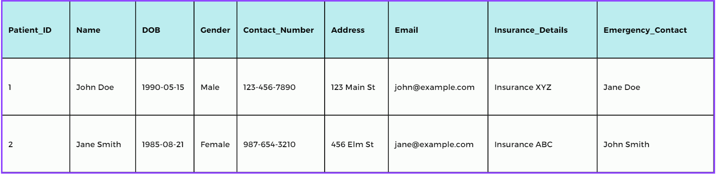  
  
  
**Second Normal Form (2NF)**

Second Normal Form (2NF) requires adherence to the following guidelines:

* The table should already meet the requirements of First Normal Form (1NF).
* The table's primary key must consist of a single column. (No non-prime attribute should rely on a subset of any candidate key of the table.) Any attribute not included in any candidate key is referred to as a non-prime attribute.

**Patient Table:**  
  
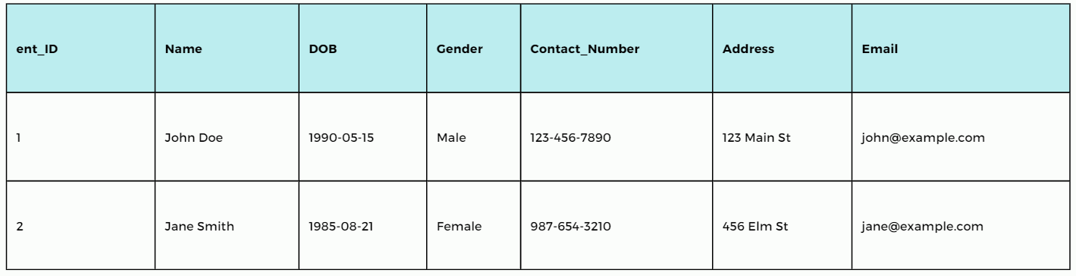

**Emergency Contact Table:**

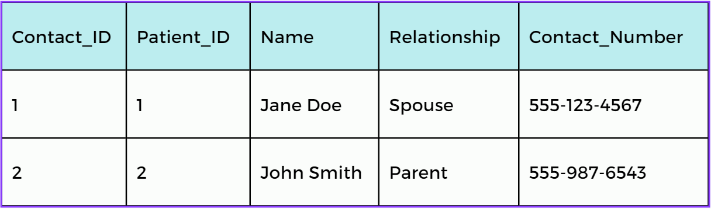

**Third Normal Form (3NF)**

Third Normal Form (3NF) mandates the following criteria:

1. The table must already satisfy the conditions of Second Normal Form (2NF).

2. It should not exhibit any transitive functional dependencies. (Eliminate transitive functional dependency of non-prime attributes on any super key.) Attributes not included in any candidate key are termed non-prime attributes, while those included in a candidate key are known as prime attributes.

There are no transitive dependencies present in this project; thus, the table also complies with 3NF requirements.

**Patient Table:**  


**Emergency Contact Table:**



**Insurance Table:**

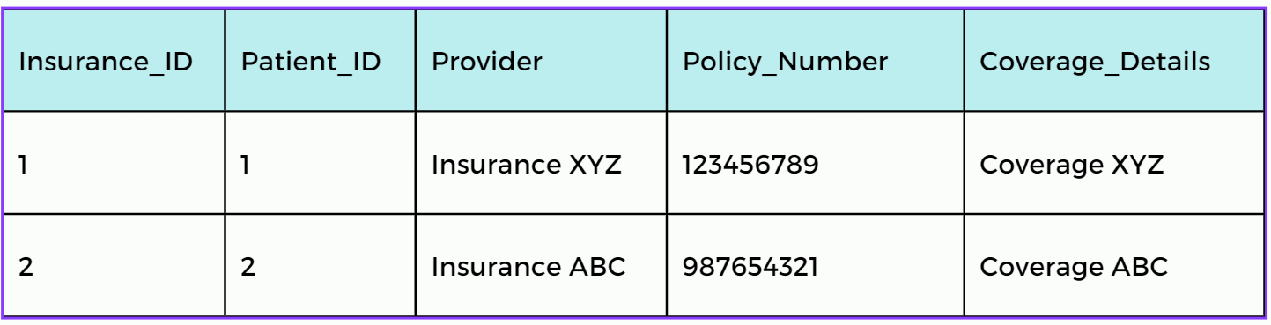

**Boyce & Codd Normal Form (BCNF)**

To validate Boyce-Codd Normal Form (BCNF) adherence, each functional dependency in the schema must have a superkey. Tables like Patient, Bills, McKinley_Health_Kits, Medical_History, Lab_Screening, Department, Nurse, Doctor, Appointment, and Prescription maintain BCNF criteria. However, Emergency_Contact and Insurance tables demonstrate violations due to non-candidate key dependencies. Decomposing these tables into smaller entities is necessary to ensure BCNF compliance. This process guarantees data integrity by eliminating redundant dependencies and upholding the requirement that every determinant (left side of the arrow) in functional dependencies is a candidate key.

**VII. SQL Queries**

**Create Tables:-**

**-- Create a new database**

CREATE DATABASE IF NOT EXISTS McKinley_Healthcare;

**-- Use the newly created database**

USE McKinley_Healthcare;

**-- Create Patient table**

CREATE TABLE IF NOT EXISTS Patient (

Net_ID INT PRIMARY KEY NOT NULL,

Name VARCHAR(100) NOT NULL,

DOB DATE,

Gender VARCHAR(10),

Contact_Number VARCHAR(20),

Address VARCHAR(255),

Email VARCHAR(255),

Phone_number VARCHAR(20)

);

**-- Create Emergency Contact table**

CREATE TABLE IF NOT EXISTS Emergency_Contact (

Contact_ID INT PRIMARY KEY NOT NULL,

Patient_Net_ID INT NOT NULL,

Name VARCHAR(100) NOT NULL,

Relationship VARCHAR(100),

Contact_Number VARCHAR(20),

FOREIGN KEY (Patient_Net_ID) REFERENCES Patient(Net_ID) ON DELETE CASCADE

);

**-- Create Insurance table**

CREATE TABLE IF NOT EXISTS Insurance (

Insurance_ID INT PRIMARY KEY NOT NULL,

Net_ID INT NOT NULL,

Insurance_Provider VARCHAR(100) NOT NULL,

Policy_Number VARCHAR(50) NOT NULL,

Coverage_Details VARCHAR(255),

FOREIGN KEY (Net_ID) REFERENCES Patient(Net_ID) ON DELETE CASCADE

)**;**

**-- Create Bills table**

CREATE TABLE IF NOT EXISTS Bills (

Bill_ID INT PRIMARY KEY NOT NULL,

Net_ID INT NOT NULL,

Total_Amount DECIMAL(10, 2) NOT NULL,

Payment_Status VARCHAR(20),

FOREIGN KEY (Net_ID) REFERENCES Patient(Net_ID) ON DELETE CASCADE

);

**-- Create McKinley Health Kits table**

CREATE TABLE IF NOT EXISTS McKinley_Health_Kits (

Health_Kit_ID INT PRIMARY KEY NOT NULL,

Net_ID INT NOT NULL,

Health_Kit_Type VARCHAR(100) NOT NULL,

Date_Taken DATE,

Quantity_Taken INT,

FOREIGN KEY (Net_ID) REFERENCES Patient(Net_ID) ON DELETE CASCADE

);

**-- Create Medical History table**

CREATE TABLE IF NOT EXISTS Medical_History (

History_ID INT PRIMARY KEY NOT NULL,

Net_ID INT NOT NULL,

Medical_Condition VARCHAR(255) NOT NULL,

Diagnosis_Date DATE,

Treatment_Plan TEXT,

FOREIGN KEY (Net_ID) REFERENCES Patient(Net_ID) ON DELETE CASCADE

);

**-- Create Lab Screening table**

CREATE TABLE IF NOT EXISTS Lab_Screening (

Screening_ID INT PRIMARY KEY NOT NULL,

Net_ID INT NOT NULL,

Test_Name VARCHAR(100) NOT NULL,

Test_Date DATE,

Test_Result VARCHAR(255),

FOREIGN KEY (Net_ID) REFERENCES Patient(Net_ID) ON DELETE CASCADE

);

**-- Create Department table**

CREATE TABLE IF NOT EXISTS Department (

Department_ID INT PRIMARY KEY NOT NULL,

Department_Name VARCHAR(100) NOT NULL,

Location VARCHAR(255) NOT NULL

);

**-- Create Nurse table**

CREATE TABLE IF NOT EXISTS Nurse (

Nurse_ID INT PRIMARY KEY NOT NULL,

Department_ID INT NOT NULL,

Name VARCHAR(100) NOT NULL,

Contact_Number VARCHAR(20),

Email VARCHAR(255),

FOREIGN KEY (Department_ID) REFERENCES Department(Department_ID) ON DELETE CASCADE

);

**-- Create Doctor table**

CREATE TABLE IF NOT EXISTS Doctor (

Doctor_ID INT PRIMARY KEY NOT NULL,

Department_ID INT NOT NULL,

Name VARCHAR(100) NOT NULL,

Specialization VARCHAR(100) NOT NULL,

Contact_Number VARCHAR(20),

Email VARCHAR(255),

FOREIGN KEY (Department_ID) REFERENCES Department(Department_ID) ON DELETE CASCADE

);

**-- Create Appointment table**

CREATE TABLE IF NOT EXISTS Appointment (

Appointment_ID INT PRIMARY KEY NOT NULL,

Net_ID INT NOT NULL,

Doctor_ID INT NOT NULL,

Appointment_Date DATETIME,

Appointment_Type VARCHAR(100),

Appointment_Status VARCHAR(50),

FOREIGN KEY (Net_ID) REFERENCES Patient(Net_ID) ON DELETE CASCADE,

FOREIGN KEY (Doctor_ID) REFERENCES Doctor(Doctor_ID) ON DELETE CASCADE

);

**-- Create Prescription table**

CREATE TABLE IF NOT EXISTS Prescription (

Prescription_ID INT PRIMARY KEY NOT NULL,

Net_ID INT NOT NULL,

Medication_Name VARCHAR(255) NOT NULL,

Dosage VARCHAR(50) NOT NULL,

Frequency VARCHAR(50) NOT NULL,

Prescription_Date DATE,

Expiration_Date DATE,

Appointment_ID INT,

FOREIGN KEY (Net_ID) REFERENCES Patient(Net_ID) ON DELETE CASCADE,

FOREIGN KEY (Appointment_ID) REFERENCES Appointment(Appointment_ID) ON DELETE SET NULL

);

**-- Inserting records into the Patient table**

INSERT INTO Patient (Net_ID, Name, DOB, Gender, Contact_Number, Address, Email, Phone_number)

VALUES

(1, 'John Doe', '1990-05-15', 'Male', '123-456-7890', '123 Main St, Anytown, USA', 'john.doe@example.com', '987-654-3210'),

(2, 'Jane Smith', '1985-10-20', 'Female', '987-654-3210', '456 Elm St, Anytown, USA', 'jane.smith@example.com', '123-456-7890'),

(3, 'Alice Johnson', '1978-08-25', 'Female', '555-555-5555', '789 Oak St, Anytown, USA', 'alice.johnson@example.com', '456-789-0123'),

(4, 'Bob Brown', '1982-03-12', 'Male', '111-222-3333', '321 Pine St, Anytown, USA', 'bob.brown@example.com', '789-012-3456'),

(5, 'Emily Wilson', '1995-11-30', 'Female', '444-555-6666', '654 Cedar St, Anytown, USA', 'emily.wilson@example.com', '012-345-6789'),

(6, 'Michael Davis', '1988-07-08', 'Male', '777-888-9999', '876 Maple St, Anytown, USA', 'michael.davis@example.com', '234-567-8901'),

(7, 'Jessica Parker', '1983-12-18', 'Female', '222-333-4444', '543 Birch St, Anytown, USA', 'jessica.parker@example.com', '345-678-9012'),

(8, 'William Turner', '1975-09-22', 'Male', '999-999-9999', '987 Oak St, Anytown, USA', 'william.turner@example.com', '456-789-0123'),

(9, 'Sophia Martinez', '1992-04-01', 'Female', '333-444-5555', '234 Pine St, Anytown, USA', 'sophia.martinez@example.com', '567-890-1234'),

(10, 'David Clark', '1980-01-05', 'Male', '666-777-8888', '678 Elm St, Anytown, USA', 'david.clark@example.com', '678-901-2345'),

(11, 'Olivia Hernandez', '1987-06-14', 'Female', '888-999-0000', '987 Cedar St, Anytown, USA', 'olivia.hernandez@example.com', '789-012-3456'),

(12, 'Daniel Lee', '1979-11-28', 'Male', '444-555-6666', '234 Birch St, Anytown, USA', 'daniel.lee@example.com', '890-123-4567'),

(13, 'Ava Nguyen', '1997-02-17', 'Female', '111-222-3333', '876 Maple St, Anytown, USA', 'ava.nguyen@example.com', '901-234-5678'),

(14, 'James Rodriguez', '1984-07-03', 'Male', '222-333-4444', '765 Oak St, Anytown, USA', 'james.rodriguez@example.com', '012-345-6789'),

(15, 'Isabella Kim', '1998-09-09', 'Female', '555-666-7777', '321 Elm St, Anytown, USA', 'isabella.kim@example.com', '123-456-7890'),

(16, 'Michael Brown', '1993-06-05', 'Male', '333-444-5555', '876 Birch St, Anytown, USA', 'michael.brown@example.com', '234-567-8901'),

(17, 'Emma Garcia', '2012-09-12', 'Female', '444-555-6666', '543 Pine St, Anytown, USA', 'emma.garcia@example.com', '345-678-9012'),

(18, 'Ethan Martinez', '1996-12-25', 'Male', '555-666-7777', '987 Cedar St, Anytown, USA', 'ethan.martinez@example.com', '456-789-0123'),

(19, 'Madison Lee', '1986-03-18', 'Female', '666-777-8888', '654 Oak St, Anytown, USA', 'madison.lee@example.com', '567-890-1234'),

(20, 'Noah Nguyen', '1999-08-30', 'Male', '777-888-9999', '321 Elm St, Anytown, USA', 'noah.nguyen@example.com', '678-901-2345'),

(21, 'Olivia Taylor', '1990-04-15', 'Female', '888-999-0000', '123 Maple St, Anytown, USA', 'olivia.taylor@example.com', '789-012-3456'),

(22, 'William Hernandez', '1980-07-20', 'Male', '999-000-1111', '789 Pine St, Anytown, USA', 'william.hernandez@example.com', '890-123-4567'),

(23, 'Ava Martinez', '2000-01-10', 'Female', '000-111-2222', '567 Cedar St, Anytown, USA', 'ava.martinez@example.com', '901-234-5678'),

(24, 'James Lee', '1975-11-28', 'Male', '111-222-3333', '876 Oak St, Anytown, USA', 'james.lee@example.com', '012-345-6789'),

(25, 'Sophia Nguyen', '1995-08-05', 'Female', '222-333-4444', '654 Elm St, Anytown, USA', 'sophia.nguyen@example.com', '123-456-7890'),

(26, 'Jacob Wilson', '1991-02-14', 'Male', '333-444-5555', '321 Birch St, Anytown, USA', 'jacob.wilson@example.com', '234-567-8901'),

(27, 'Mia Thompson', '1988-05-20', 'Female', '444-555-6666', '987 Cedar St, Anytown, USA', 'mia.thompson@example.com', '345-678-9012'),

(28, 'Ethan Hall', '1994-10-10', 'Male', '555-666-7777', '654 Elm St, Anytown, USA', 'ethan.hall@example.com', '456-789-0123'),

(29, 'Charlotte Martinez', '1997-03-28', 'Female', '666-777-8888', '321 Oak St, Anytown, USA', 'charlotte.martinez@example.com', '567-890-1234'),

(30, 'Alexander Rodriguez', '1992-08-07', 'Male', '777-888-9999', '876 Pine St, Anytown, USA', 'alexander.rodriguez@example.com', '678-901-2345'),

(31, 'Madison Garcia', '1987-12-15', 'Female', '888-999-0000', '543 Maple St, Anytown, USA', 'madison.garcia@example.com', '789-012-3456'),

(32, 'William Clark', '2008-01-02', 'Male', '999-000-1111', '234 Cedar St, Anytown, USA', 'william.clark@example.com', '890-123-4567'),

(33, 'Ava Lopez', '1996-06-19', 'Female', '000-111-2222', '987 Birch St, Anytown, USA', 'ava.lopez@example.com', '901-234-5678'),

(34, 'James Young', '1990-09-25', 'Male', '111-222-3333', '654 Oak St, Anytown, USA', 'james.young@example.com', '012-345-6789'),

(35, 'Sophia Adams', '2010-04-08', 'Female', '222-333-4444', '321 Cedar St, Anytown, USA', 'sophia.adams@example.com', '123-456-7890'),

(36, 'Daniel Martin', '2000-11-13', 'Male', '333-444-5555', '876 Pine St, Anytown, USA', 'daniel.martin@example.com', '234-567-8901'),

(37, 'Olivia Turner', '1994-10-30', 'Female', '444-555-6666', '543 Elm St, Anytown, USA', 'olivia.turner@example.com', '345-678-9012'),

(38, 'Noahi Perez', '1988-07-05', 'Female', '555-666-7777', '234 Birch St, Anytown, USA', 'noah.perez@example.com', '456-789-0123'),

(39, 'Isabella Wright', '1999-12-18', 'Female', '666-777-8888', '987 Maple St, Anytown, USA', 'isabella.wright@example.com', '567-890-1234'),

(40, 'Elijah Scott', '2015-03-22', 'Female', '777-888-9999', '654 Oak St, Anytown, USA', 'elijah.scott@example.com', '678-901-2345');

**-- Inserting records into the Emergency_Contact table**

INSERT INTO Emergency_Contact (Contact_ID, Patient_Net_ID, Name, Relationship, Contact_Number)

VALUES

(1, 1, 'Mary Doe', 'Spouse', '555-555-5555'),

(2, 2, 'Bob Smith', 'Sibling', '666-666-6666'),

(3, 3, 'Alice Johnson', 'Spouse', '777-777-7777'),

(4, 4, 'Jane Brown', 'Sibling', '888-888-8888'),

(5, 5, 'Michael Wilson', 'Parent', '999-999-9999'),

(6, 6, 'Sarah Davis', 'Spouse', '111-111-1111'),

(7, 7, 'Mark Parker', 'Sibling', '222-222-2222'),

(8, 8, 'Laura Turner', 'Spouse', '333-333-3333'),

(9, 9, 'Chris Martinez', 'Sibling', '444-444-4444'),

(10, 10, 'Emily Clark', 'Parent', '555-555-5555'),

(11, 11, 'Daniel Hernandez', 'Spouse', '666-666-6666'),

(12, 12, 'Lily Lee', 'Parent', '777-777-7777'),

(13, 13, 'Ryan Nguyen', 'Sibling', '888-888-8888'),

(14, 14, 'Sophia Rodriguez', 'Spouse', '999-999-9999'),

(15, 15, 'Michael Kim', 'Sibling', '000-000-0000'),

(16, 16, 'Jessica Brown', 'Spouse', '888-999-0000'),

(17, 17, 'David Garcia', 'Sibling', '999-000-1111'),

(18, 18, 'Sophia Martinez', 'Parent', '000-111-2222'),

(19, 19, 'Andrew Lee', 'Sibling', '111-222-3333'),

(20, 20, 'Emily Nguyen', 'Spouse', '222-333-4444'),

(21, 21, 'Ethan Taylor', 'Parent', '555-666-7777'),

(22, 22, 'Olivia Hernandez', 'Spouse', '666-777-8888'),

(23, 23, 'Emily Martinez', 'Sibling', '777-888-9999'),

(24, 24, 'Emma Lee', 'Child', '888-999-0000'),

(25, 25, 'Noah Nguyen', 'Parent', '999-000-1111');

**-- Inserting records into the Insurance table**

INSERT INTO Insurance (Insurance_ID, Net_ID, Insurance_Provider, Policy_Number, Coverage_Details)

VALUES

(1, 1, 'HealthCare Inc.', 'HC123456', 'Full coverage'),

(2, 2, 'MediCare', 'MC789012', 'Basic coverage'),

(3, 3, 'HealthPlus', 'HP345678', 'Dental and vision coverage'),

(4, 4, 'Wellness Insurance', 'WI901234', 'Wellness programs coverage'),

(5, 5, 'FamilyCare', 'FC567890', 'Family coverage'),

(6, 6, 'HealthGuard', 'HG678901', 'Comprehensive coverage'),

(7, 7, 'MediHealth', 'MH456789', 'Medication and treatment coverage'),

(8, 8, 'CareFirst', 'CF234567', 'Primary care and specialist coverage'),

(9, 9, 'SeniorCare', 'SC123890', 'Elderly care coverage'),

(10, 10, 'WellBeing', 'WB789012', 'Health and wellness coverage'),

(11, 11, 'FamilyHealth', 'FH567123', 'Family medical coverage'),

(12, 12, 'LifeCare', 'LC890456', 'Life-saving treatment coverage'),

(13, 13, 'DentalCare', 'DC123567', 'Dental treatment coverage'),

(14, 14, 'SecureHealth', 'SH456789', 'Secure health coverage'),

(15, 15, 'Guardian Insurance', 'GI789012', 'Comprehensive health coverage'),

(16, 16, 'HealthCare Inc.', 'HC123457', 'Full coverage'),

(17, 17, 'MediCare', 'MC789013', 'Basic coverage'),

(18, 18, 'HealthPlus', 'HP345679', 'Dental and vision coverage'),

(19, 19, 'Wellness Insurance', 'WI901235', 'Wellness programs coverage'),

(20, 20, 'FamilyCare', 'FC567891', 'Family coverage'),

(21, 21, 'FamilyCare', 'FC234567', 'Family coverage'),

(22, 22, 'HealthPlus', 'HP456789', 'Basic coverage'),

(23, 23, 'MediCare', 'MC678901', 'Dental coverage'),

(24, 24, 'Wellness Insurance', 'WI123456', 'Wellness programs coverage'),

(25, 25, 'HealthCare Inc.', 'HC345678', 'Full coverage');

**-- Inserting records into the Bills table**

INSERT INTO Bills (Bill_ID, Net_ID, Total_Amount, Payment_Status)

VALUES

(1, 1, 100.00, 'Paid'),

(2, 2, 150.00, 'Unpaid'),

(3, 3, 200.00, 'Paid'),

(4, 4, 120.00, 'Unpaid'),

(5, 5, 180.00, 'Paid'),

(6, 6, 220.00, 'Unpaid'),

(7, 7, 130.00, 'Paid'),

(8, 8, 170.00, 'Unpaid'),

(9, 9, 190.00, 'Paid'),

(10, 10, 210.00, 'Unpaid'),

(11, 11, 140.00, 'Paid'),

(12, 12, 160.00, 'Unpaid'),

(13, 13, 240.00, 'Paid'),

(14, 14, 260.00, 'Unpaid'),

(15, 15, 280.00, 'Paid'),

(16, 16, 150.00, 'Unpaid'),

(17, 17, 200.00, 'Paid'),

(18, 18, 220.00, 'Unpaid'),

(19, 19, 130.00, 'Paid'),

(20, 20, 170.00, 'Unpaid'),

(21, 21, 180.00, 'Unpaid'),

(22, 22, 250.00, 'Paid'),

(23, 23, 200.00, 'Unpaid'),

(24, 24, 300.00, 'Unpaid'),

(25, 25, 150.00, 'Paid');

**-- Inserting records into the McKinley_Health_Kits table**

INSERT INTO McKinley_Health_Kits (Health_Kit_ID, Net_ID, Health_Kit_Type, Date_Taken, Quantity_Taken)

VALUES

(1, 1, 'First Aid Kit', '2024-04-15', 1),

(2, 2, 'Medicine Kit', '2024-04-16', 2),

(3, 3, 'Home Health Kit', '2024-04-17', 1),

(4, 4, 'Wellness Kit', '2024-04-18', 1),

(5, 5, 'Family Health Kit', '2024-04-19', 3),

(6, 6, 'Emergency Kit', '2024-04-20', 1),

(7, 7, 'Medication Kit', '2024-04-21', 2),

(8, 8, 'Travel Health Kit', '2024-04-22', 1),

(9, 9, 'Senior Health Kit', '2024-04-23', 1),

(10, 10, 'Wellness Kit', '2024-04-24', 2),

(11, 11, 'Family Health Kit', '2024-04-25', 3),

(12, 12, 'Emergency Kit', '2024-04-26', 1),

(13, 13, 'Medicine Kit', '2024-04-27', 2),

(14, 14, 'Home Health Kit', '2024-04-28', 1),

(15, 15, 'First Aid Kit', '2024-04-29', 1),

(16, 16, 'First Aid Kit', '2024-04-30', 1),

(17, 17, 'Medicine Kit', '2024-05-01', 2),

(18, 18, 'Home Health Kit', '2024-05-02', 1),

(19, 19, 'Wellness Kit', '2024-05-03', 1),

(20, 20, 'Family Health Kit', '2024-05-04', 3),

(21, 21, 'Home Health Kit', '2024-05-30', 1),

(22, 22, 'Family Health Kit', '2024-06-01', 2),

(23, 23, 'Wellness Kit', '2024-06-02', 1),

(24, 24, 'First Aid Kit', '2024-06-03', 1),

(25, 25, 'Medicine Kit', '2024-06-04', 3);

**-- Inserting records into the Medical_History table**

INSERT INTO Medical_History (History_ID, Net_ID, Medical_Condition, Diagnosis_Date, Treatment_Plan)

VALUES

(1, 1, 'Hypertension', '2020-01-01', 'Prescribed medication and regular checkups'),

(2, 2, 'Diabetes', '2018-05-10', 'Insulin therapy and dietary changes'),

(3, 3, 'Asthma', '2019-07-15', 'Inhaler usage and avoiding triggers'),

(4, 4, 'Depression', '2021-03-20', 'Therapy sessions and antidepressant medication'),

(5, 5, 'Allergies', '2017-09-25', 'Avoidance of allergens and antihistamine medication'),

(6, 6, 'High Cholesterol', '2019-02-12', 'Cholesterol-lowering medication and diet changes'),

(7, 7, 'Flu', '2023-12-05', 'Antiviral medication and rest'),

(8, 8, 'Arthritis', '2016-08-30', 'Pain management medication and physical therapy'),

(9, 9, 'Anxiety', '2022-06-17', 'Therapy sessions and anti-anxiety medication'),

(10, 10, 'Migraine', '2015-03-22', 'Migraine medication and lifestyle changes'),

(11, 11, 'Heart Disease', '2019-10-10', 'Cardiac medication and lifestyle modifications'),

(12, 12, 'Eczema', '2018-04-02', 'Topical creams and avoiding triggers'),

(13, 13, 'Dental Cavities', '2023-02-28', 'Dental fillings and oral hygiene practices'),

(14, 14, 'Obesity', '2017-11-15', 'Dietary changes and exercise regimen'),

(15, 15, 'Insomnia', '2020-09-10', 'Sleep hygiene practices and relaxation techniques'),

(16, 16, 'Anemia', '2023-11-10', 'Iron supplements and dietary changes'),

(17, 17, 'Hypothyroidism', '2016-07-05', 'Thyroid hormone replacement therapy'),

(18, 18, 'Gastritis', '2022-05-15', 'Antacids and dietary modifications'),

(19, 19, 'Back Pain', '2015-09-20', 'Physical therapy and pain medication'),

(20, 20, 'Insomnia', '2023-03-25', 'Sleep hygiene practices and relaxation techniques'),

(21, 21, 'Migraine', '2023-10-20', 'Prescription medication and lifestyle modifications'),

(22, 22, 'Diabetes', '2018-05-15', 'Insulin therapy and dietary changes'),

(23, 23, 'Anxiety', '2022-08-25', 'Therapy and medication'),

(24, 24, 'Hypertension', '2017-09-30', 'Medication and lifestyle changes'),

(25, 25, 'Allergies', '2023-04-10', 'Antihistamines and allergen avoidance'),

(26, 26, 'Diabetes', '2023-04-10', 'Insulin therapy and dietary changes'),

(27, 27, 'Diabetes', '2023-09-10', 'Insulin therapy and dietary changes'),

(28, 28, 'Diabetes', '2023-06-10', 'Insulin therapy and dietary changes'),

(29, 29, 'Hypertension', '2023-04-10', 'Medication and lifestyle changes'),

(30, 30, 'Anxiety', '2023-08-10', 'Therapy and medication'),

(31, 31, 'Anxiety', '2023-02-10', 'Therapy and medication'),

(32, 32, 'Migraine', '2023-04-10', 'rescription medication and lifestyle modifications'),

(33, 33, 'Migraine', '2023-06-10', 'rescription medication and lifestyle modifications');

**-- Inserting records into the Lab_Screening table**

INSERT INTO Lab_Screening (Screening_ID, Net_ID, Test_Name, Test_Date, Test_Result)

VALUES

(1, 1, 'Blood Pressure', '2024-04-10', 'Normal'),

(2, 2, 'Blood Sugar', '2024-04-12', 'High'),

(3, 3, 'Lipid Profile', '2024-04-14', 'Normal'),

(4, 4, 'Thyroid Function', '2024-04-16', 'Abnormal'),

(5, 5, 'Allergy Panel', '2024-04-18', 'Positive'),

(6, 6, 'Liver Function Test', '2024-04-20', 'Normal'),

(7, 7, 'Kidney Function Test', '2024-04-22', 'Normal'),

(8, 8, 'Complete Blood Count', '2024-04-24', 'Normal'),

(9, 9, 'Urinalysis', '2024-04-26', 'Normal'),

(10, 10, 'Thyroid Function', '2024-04-28', 'Normal'),

(11, 11, 'Blood Pressure', '2024-04-30', 'High'),

(12, 12, 'Blood Sugar', '2024-05-02', 'Normal'),

(13, 13, 'Lipid Profile', '2024-05-04', 'High'),

(14, 14, 'Thyroid Function', '2024-05-06', 'Normal'),

(15, 15, 'Allergy Panel', '2024-05-08', 'Negative'),

(16, 16, 'Complete Blood Count', '2024-05-10', 'Normal'),

(17, 17, 'Liver Function Test', '2024-05-12', 'Abnormal'),

(18, 18, 'Kidney Function Test', '2024-05-14', 'Normal'),

(19, 19, 'Thyroid Function', '2024-05-16', 'Normal'),

(20, 20, 'Blood Pressure', '2024-05-18', 'High'),

(21, 21, 'Blood Sugar', '2024-06-10', 'Normal'),

(22, 22, 'Cholesterol', '2024-06-12', 'High'),

(23, 23, 'Stress Test', '2024-06-14', 'Normal'),

(24, 24, 'Blood Pressure', '2024-06-16', 'High'),

(25, 25, 'Allergy Test', '2024-06-18', 'Positive');

**-- Inserting records into the Department table**

INSERT INTO Department (Department_ID, Department_Name, Location)

VALUES

(1, 'Cardiology', 'Main Building, 1st Floor'),

(2, 'Pediatrics', 'East Wing, 2nd Floor'),

(3, 'Dermatology', 'West Wing, 3rd Floor'),

(4, 'Orthopedics', 'North Wing, 4th Floor'),

(5, 'Neurology', 'South Wing, 5th Floor'),

(6, 'Oncology', 'Main Building, 2nd Floor'),

(7, 'Gastroenterology', 'East Wing, 3rd Floor'),

(8, 'Endocrinology', 'West Wing, 4th Floor'),

(9, 'Psychiatry', 'North Wing, 6th Floor'),

(10, 'Pulmonology', 'South Wing, 7th Floor'),

(11, 'Ophthalmology', 'Main Building, 3rd Floor'),

(12, 'Rheumatology', 'East Wing, 4th Floor'),

(13, 'Urology', 'West Wing, 5th Floor'),

(14, 'Dentistry', 'North Wing, 8th Floor'),

(15, 'Radiology', 'South Wing, 9th Floor');

**-- Inserting records into the Nurse table**

INSERT INTO Nurse (Nurse_ID, Department_ID, Name, Contact_Number, Email)

VALUES

(1, 1, 'Sarah Johnson', '111-111-1111', 'sarah.johnson@example.com'),

(2, 2, 'Michael Williams', '222-222-2222', 'michael.williams@example.com'),

(3, 3, 'Emily Brown', '333-333-3333', 'emily.brown@example.com'),

(4, 4, 'Daniel Jones', '444-444-4444', 'daniel.jones@example.com'),

(5, 5, 'Jessica Taylor', '555-555-5555', 'jessica.taylor@example.com'),

(6, 6, 'Jennifer Martinez', '666-666-6666', 'jennifer.martinez@example.com'),

(7, 7, 'Andrew Garcia', '777-777-7777', 'andrew.garcia@example.com'),

(8, 8, 'Stephanie Rodriguez', '888-888-8888', 'stephanie.rodriguez@example.com'),

(9, 9, 'David Hernandez', '999-999-9999', 'david.hernandez@example.com'),

(10, 10, 'Jessica Kim', '000-000-0000', 'jessica.kim@example.com'),

(11, 11, 'Daniel Nguyen', '111-222-3333', 'daniel.nguyen@example.com'),

(12, 12, 'Sophia Lee', '222-333-4444', 'sophia.lee@example.com'),

(13, 13, 'Michael Smith', '333-444-5555', 'michael.smith@example.com'),

(14, 14, 'Emily Johnson', '444-555-6666', 'emily.johnson@example.com'),

(15, 15, 'Daniel Park', '555-666-7777', 'daniel.park@example.com');

**-- Inserting records into the Doctor table**

INSERT INTO Doctor (Doctor_ID, Department_ID, Name, Specialization, Contact_Number, Email)

VALUES

(1, 1, 'Dr. Emily Carter', 'Cardiologist', '333-333-3333', 'emily.carter@example.com'),

(2, 2, 'Dr. James Anderson', 'Pediatrician', '444-444-4444', 'james.anderson@example.com'),

(3, 3, 'Dr. Jessica Brown', 'Dermatologist', '555-555-5555', 'jessica.brown@example.com'),

(4, 4, 'Dr. Michael Smith', 'Orthopedic Surgeon', '666-666-6666', 'michael.smith@example.com'),

(5, 5, 'Dr. Jennifer Lee', 'Neurologist', '777-777-7777', 'jennifer.lee@example.com'),

(6, 6, 'Dr. Andrew Garcia', 'Oncologist', '888-888-8888', 'andrew.garcia@example.com'),

(7, 7, 'Dr. Stephanie Rodriguez', 'Gastroenterologist', '999-999-9999', 'stephanie.rodriguez@example.com'),

(8, 8, 'Dr. David Hernandez', 'Endocrinologist', '000-000-0000', 'david.hernandez@example.com'),

(9, 9, 'Dr. Jessica Kim', 'Psychiatrist', '111-111-1111', 'jessica.kim@example.com'),

(10, 10, 'Dr. Daniel Nguyen', 'Pulmonologist', '222-222-2222', 'daniel.nguyen@example.com'),

(11, 11, 'Dr. Sophia Lee', 'Ophthalmologist', '333-333-3333', 'sophia.lee@example.com'),

(12, 12, 'Dr. Michael Smith', 'Rheumatologist', '444-444-4444', 'michael.smith@example.com'),

(13, 13, 'Dr. Emily Johnson', 'Urologist', '555-555-5555', 'emily.johnson@example.com'),

(14, 14, 'Dr. Daniel Park', 'Dentist', '666-666-6666', 'daniel.park@example.com'),

(15, 15, 'Dr. Jessica Taylor', 'Radiologist', '777-777-7777', 'jessica.taylor@example.com'),

(16, 1, 'Dr. Olivia Wilson', 'Cardiologist', '123-456-7890', 'olivia.wilson@example.com'),

(17, 2, 'Dr. William Martinez', 'Pediatrician', '234-567-8901', 'william.martinez@example.com'),

(18, 3, 'Dr. Sophia Brown', 'Dermatologist', '345-678-9012', 'sophia.brown@example.com'),

(19, 4, 'Dr. Noah Johnson', 'Orthopedic Surgeon', '456-789-0123', 'noah.johnson@example.com'),

(20, 5, 'Dr. Emma Rodriguez', 'Neurologist', '567-890-1234', 'emma.rodriguez@example.com'),

(21, 6, 'Dr. Ethan Garcia', 'Oncologist', '678-901-2345', 'ethan.garcia@example.com'),

(22, 7, 'Dr. Olivia Hernandez', 'Gastroenterologist', '789-012-3456', 'olivia.hernandez@example.com'),

(23, 8, 'Dr. William Kim', 'Endocrinologist', '890-123-4567', 'william.kim@example.com'),

(24, 9, 'Dr. Ava Nguyen', 'Psychiatrist', '901-234-5678', 'ava.nguyen@example.com'),

(25, 10, 'Dr. James Lee', 'Pulmonologist', '012-345-6789', 'james.lee@example.com'),

(26, 11, 'Dr. Sophia Hernandez', 'Ophthalmologist', '123-456-7890', 'sophia.hernandez@example.com'),

(27, 12, 'Dr. Ethan Smith', 'Rheumatologist', '234-567-8901', 'ethan.smith@example.com'),

(28, 13, 'Dr. Olivia Johnson', 'Urologist', '345-678-9012', 'olivia.johnson@example.com'),

(29, 14, 'Dr. William Park', 'Dentist', '456-789-0123', 'william.park@example.com'),

(30, 15, 'Dr. Emma Taylor', 'Radiologist', '567-890-1234', 'emma.taylor@example.com');

**-- Inserting records into the Appointment table**

INSERT INTO Appointment (Appointment_ID, Net_ID, Doctor_ID, Appointment_Date, Appointment_Type, Appointment_Status)

VALUES

(1, 1, 1, '2024-04-20 10:00:00', 'Follow-up', 'Scheduled'),

(2, 2, 1, '2024-04-21 11:00:00', 'Check-up', 'Confirmed'),

(3, 3, 3, '2024-04-22 12:00:00', 'Consultation', 'Scheduled'),

(4, 4, 4, '2024-04-23 13:00:00', 'Procedure', 'Confirmed'),

(5, 5, 5, '2024-04-24 14:00:00', 'Follow-up', 'Scheduled'),

(6, 6, 6, '2024-04-25 15:00:00', 'Check-up', 'Confirmed'),

(7, 7, 7, '2024-04-26 16:00:00', 'Consultation', 'Scheduled'),

(8, 8, 7, '2024-04-27 17:00:00', 'Procedure', 'Confirmed'),

(9, 9, 8, '2024-04-28 18:00:00', 'Follow-up', 'Scheduled'),

(10, 10, 10, '2024-04-29 19:00:00', 'Check-up', 'Confirmed'),

(11, 11, 11, '2024-04-30 20:00:00', 'Consultation', 'Scheduled'),

(12, 12, 12, '2024-05-01 21:00:00', 'Procedure', 'Confirmed'),

(13, 13, 13, '2024-05-02 22:00:00', 'Follow-up', 'Scheduled'),

(14, 14, 14, '2024-05-03 23:00:00', 'Check-up', 'Confirmed'),

(15, 15, 15, '2024-05-04 08:00:00', 'Consultation', 'Scheduled'),

(16, 16, 15, '2024-05-20 10:00:00', 'Follow-up', 'Scheduled'),

(17, 17, 16, '2024-05-21 11:00:00', 'Check-up', 'Confirmed'),

(18, 18, 18, '2024-05-22 12:00:00', 'Consultation', 'Scheduled'),

(19, 19, 19, '2024-05-23 13:00:00', 'Procedure', 'Confirmed'),

(20, 20, 20, '2024-05-24 14:00:00', 'Follow-up', 'Scheduled'),

(21, 21, 26, '2024-06-20 10:00:00', 'Follow-up', 'Scheduled'),

(22, 22, 27, '2024-06-21 11:00:00', 'Check-up', 'Confirmed'),

(23, 23, 18, '2024-06-22 12:00:00', 'Consultation', 'Scheduled'),

(24, 24, 29, '2024-06-23 13:00:00', 'Procedure', 'Confirmed'),

(25, 25, 23, '2024-06-24 14:00:00', 'Follow-up', 'Scheduled');

**-- Inserting records into the Prescription table**

INSERT INTO Prescription (Prescription_ID, Net_ID, Medication_Name, Dosage, Frequency, Prescription_Date, Expiration_Date, Appointment_ID)

VALUES

(1, 1, 'Lisinopril', '10mg', 'Once daily', '2024-04-20', '2024-05-20', 1),

(2, 2, 'Insulin', '10 units', 'Before meals', '2024-04-21', '2024-05-21', 2),

(3, 3, 'Clobetasol', '0.05%', 'Apply twice daily', '2024-04-22', '2024-05-22', 3),

(4, 4, 'Ibuprofen', '400mg', 'As needed', '2024-04-23', '2024-05-23', 4),

(5, 5, 'Sumatriptan', '50mg', 'As needed for migraines', '2024-04-24', '2024-05-24', 5),

(6, 6, 'Simvastatin', '20mg', 'Once daily at bedtime', '2024-04-25', '2024-05-25', 6),

(7, 7, 'Omeprazole', '20mg', 'Once daily before breakfast', '2024-04-26', '2024-05-26', 7),

(8, 8, 'Levothyroxine', '50mcg', 'Once daily before breakfast', '2024-04-27', '2024-05-27', 8),

(9, 9, 'Alprazolam', '0.5mg', 'As needed for anxiety', '2024-04-28', '2024-05-28', 9),

(10, 10, 'Sumatriptan', '100mg', 'As needed for migraines', '2024-04-29', '2024-05-29', 10),

(11, 11, 'Atorvastatin', '20mg', 'Once daily at bedtime', '2024-04-30', '2024-05-30', 11),

(12, 12, 'Hydrocortisone', '1%', 'Apply to affected area', '2024-05-01', '2024-06-01', 12),

(13, 13, 'Fluoride', '1mg', 'Once daily', '2024-05-02', '2024-06-02', 13),

(14, 14, 'Orlistat', '120mg', 'Three times daily with meals', '2024-05-03', '2024-06-03', 14),

(15, 15, 'Zolpidem', '10mg', 'At bedtime as needed', '2024-05-04', '2024-06-04', 15),

(16, 16, 'Ferrous Sulfate', '325mg', 'Once daily', '2024-05-20', '2024-06-20', 16),

(17, 17, 'Levothyroxine', '50mcg', 'Once daily before breakfast', '2024-05-21', '2024-06-21', 17),

(18, 18, 'Omeprazole', '20mg', 'Once daily before breakfast', '2024-05-22', '2024-06-22', 18),

(19, 19, 'Ibuprofen', '400mg', 'As needed', '2024-05-23', '2024-06-23', 19),

(20, 20, 'Zolpidem', '10mg', 'At bedtime as needed', '2024-05-24', '2024-06-24', 20),

(21, 21, 'Sumatriptan', '50mg', 'As needed for migraine attacks', '2024-06-20', '2024-07-20', 21),

(22, 22, 'Insulin', '10 units', 'Before meals', '2024-06-21', '2024-07-21', 22),

(23, 23, 'Sertraline', '50mg', 'Once daily', '2024-06-22', '2024-07-22', 23),

(24, 24, 'Lisinopril', '10mg', 'Once daily', '2024-06-23', '2024-07-23', 24),

(25, 25, 'Cetirizine', '10mg', 'As needed for allergies', '2024-06-24', '2024-07-24', 25);

**Queries:-**

**1. Total number of patients by gender:**

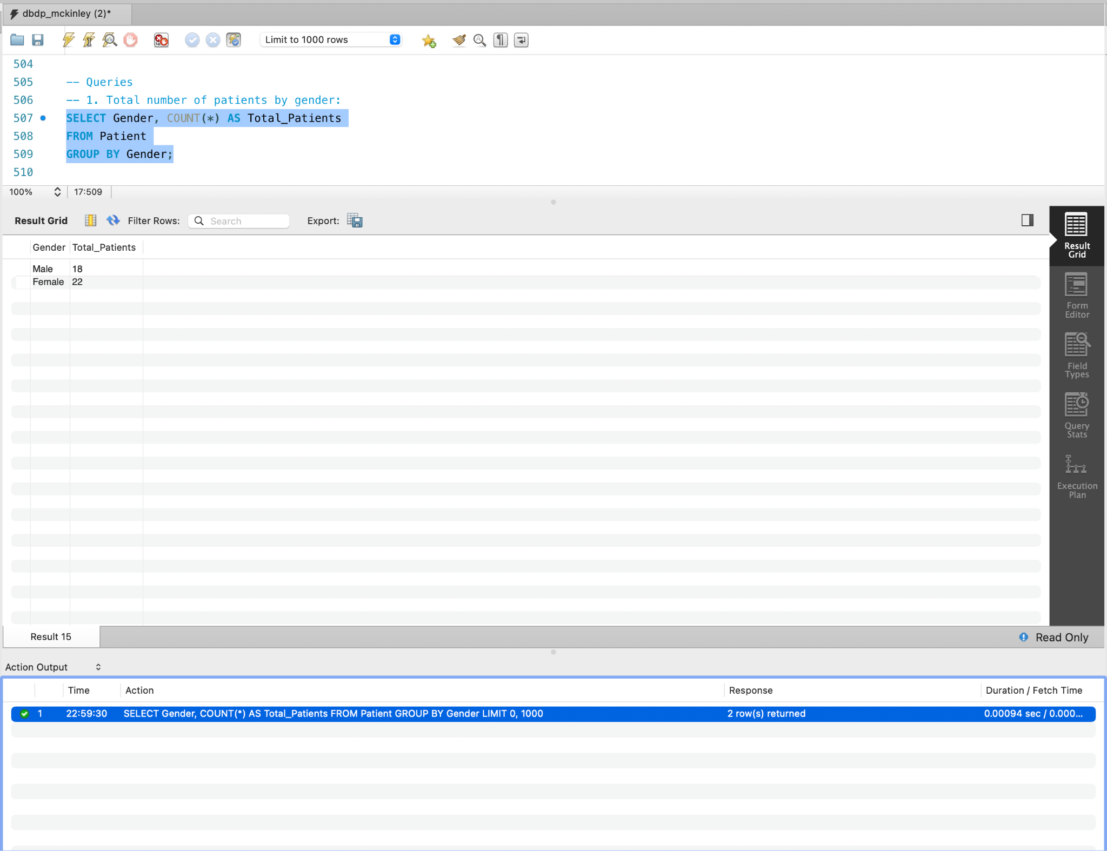

**2. Average total amount of bills by payment status:**

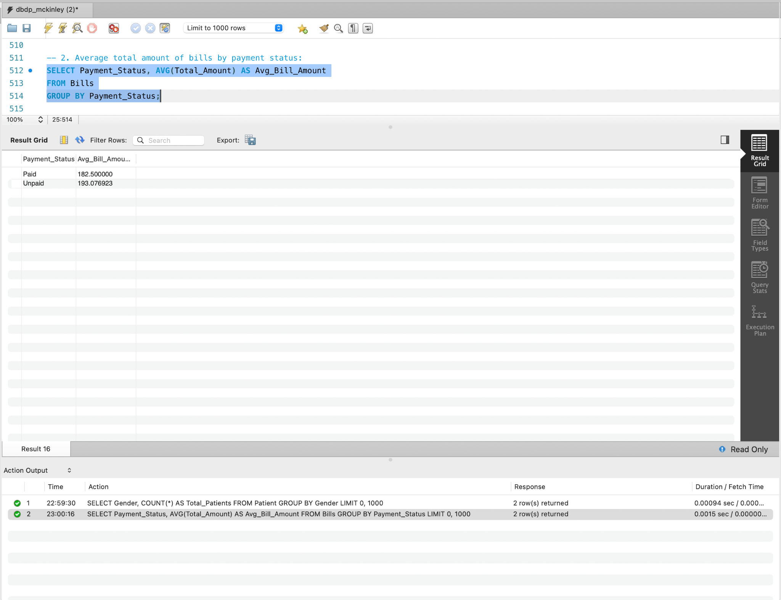

**3 . Number of appointments per doctor:**

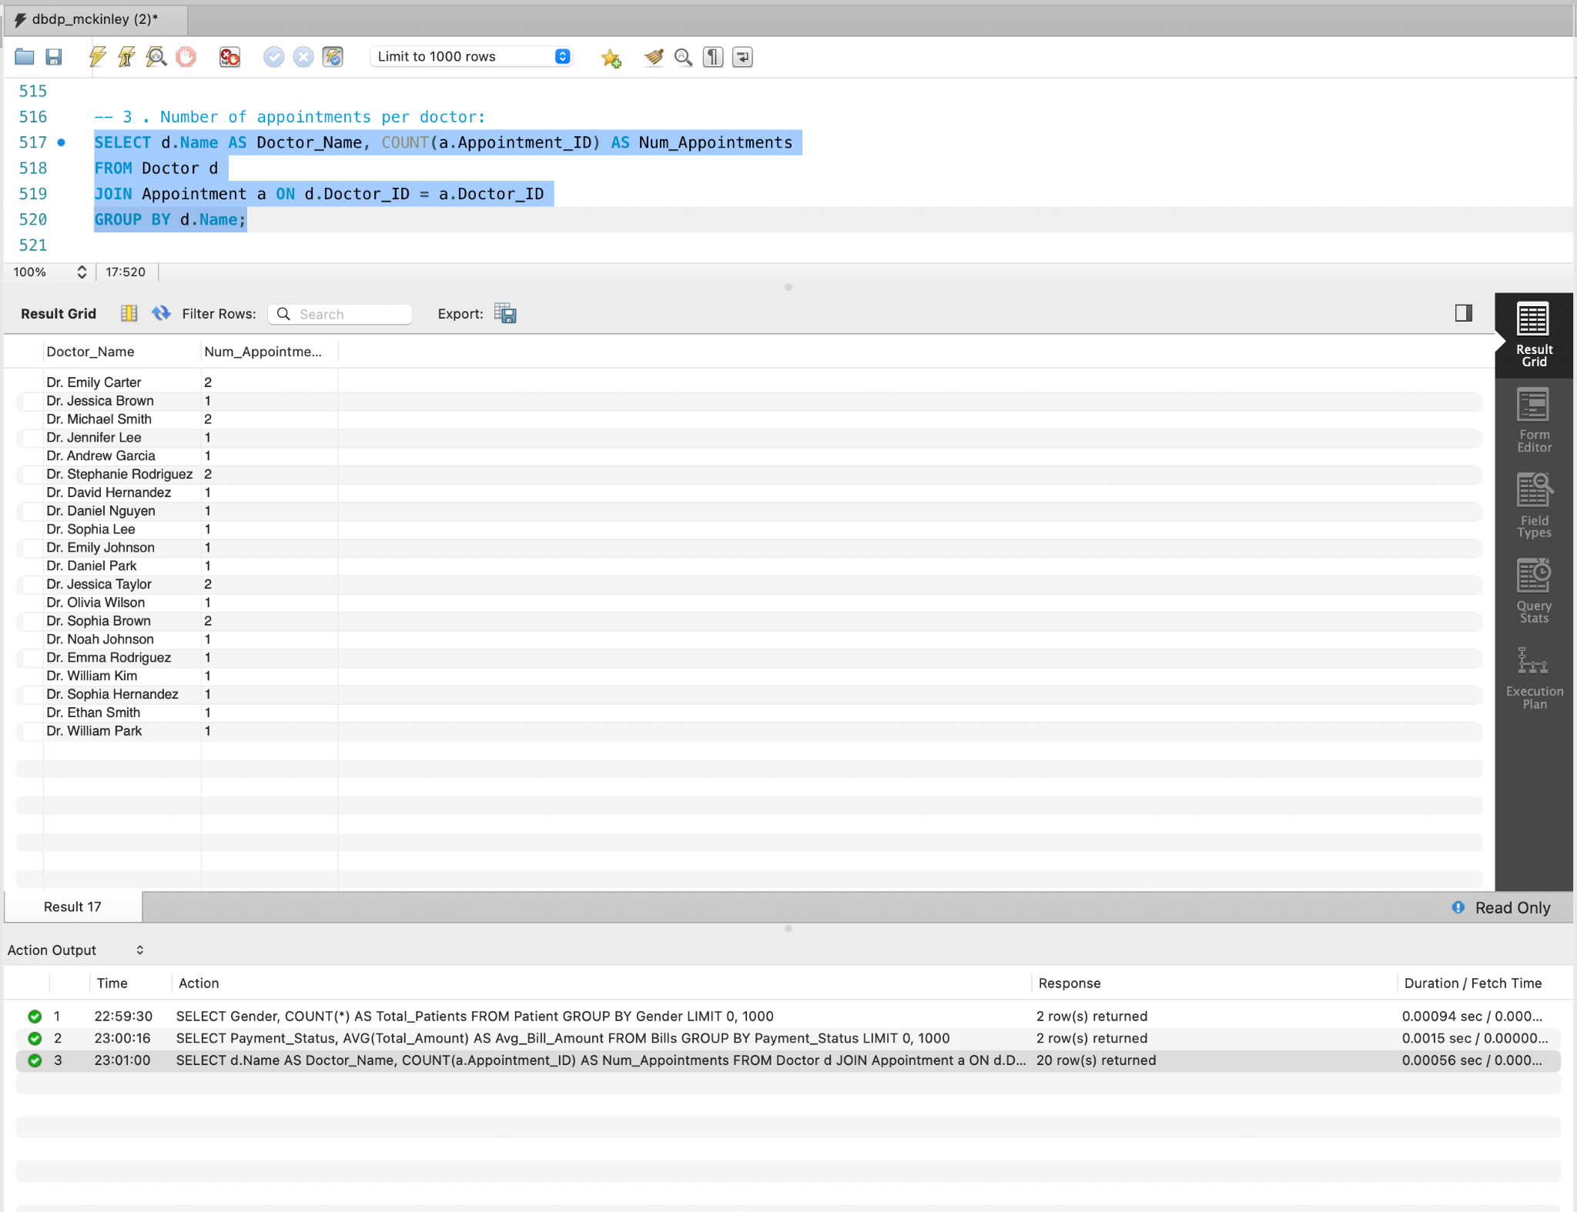

**4. Top 5 most common medical conditions:**

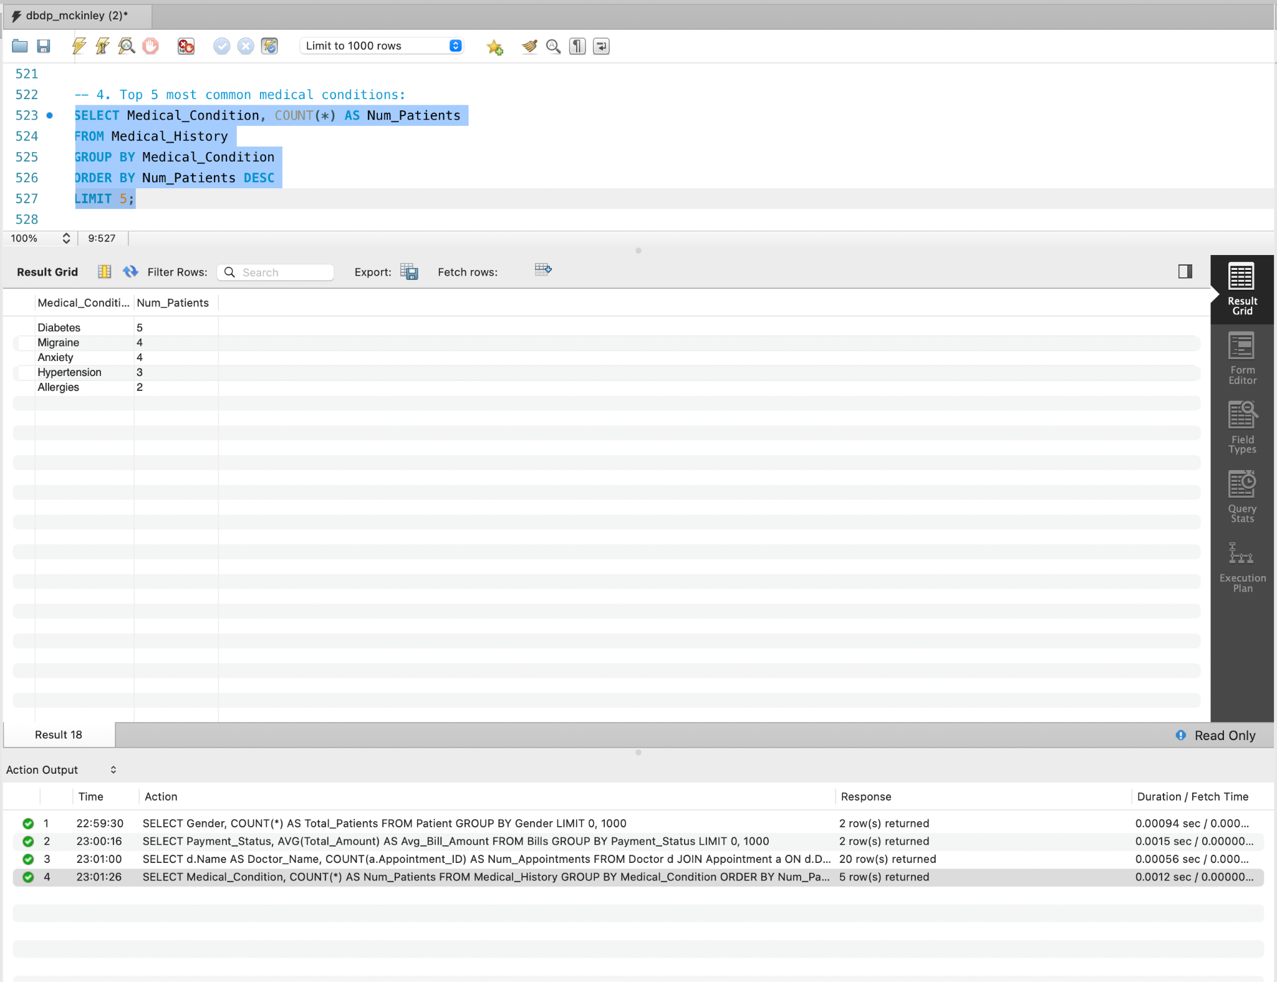

**5. Total quantity of each health kit type distributed:**

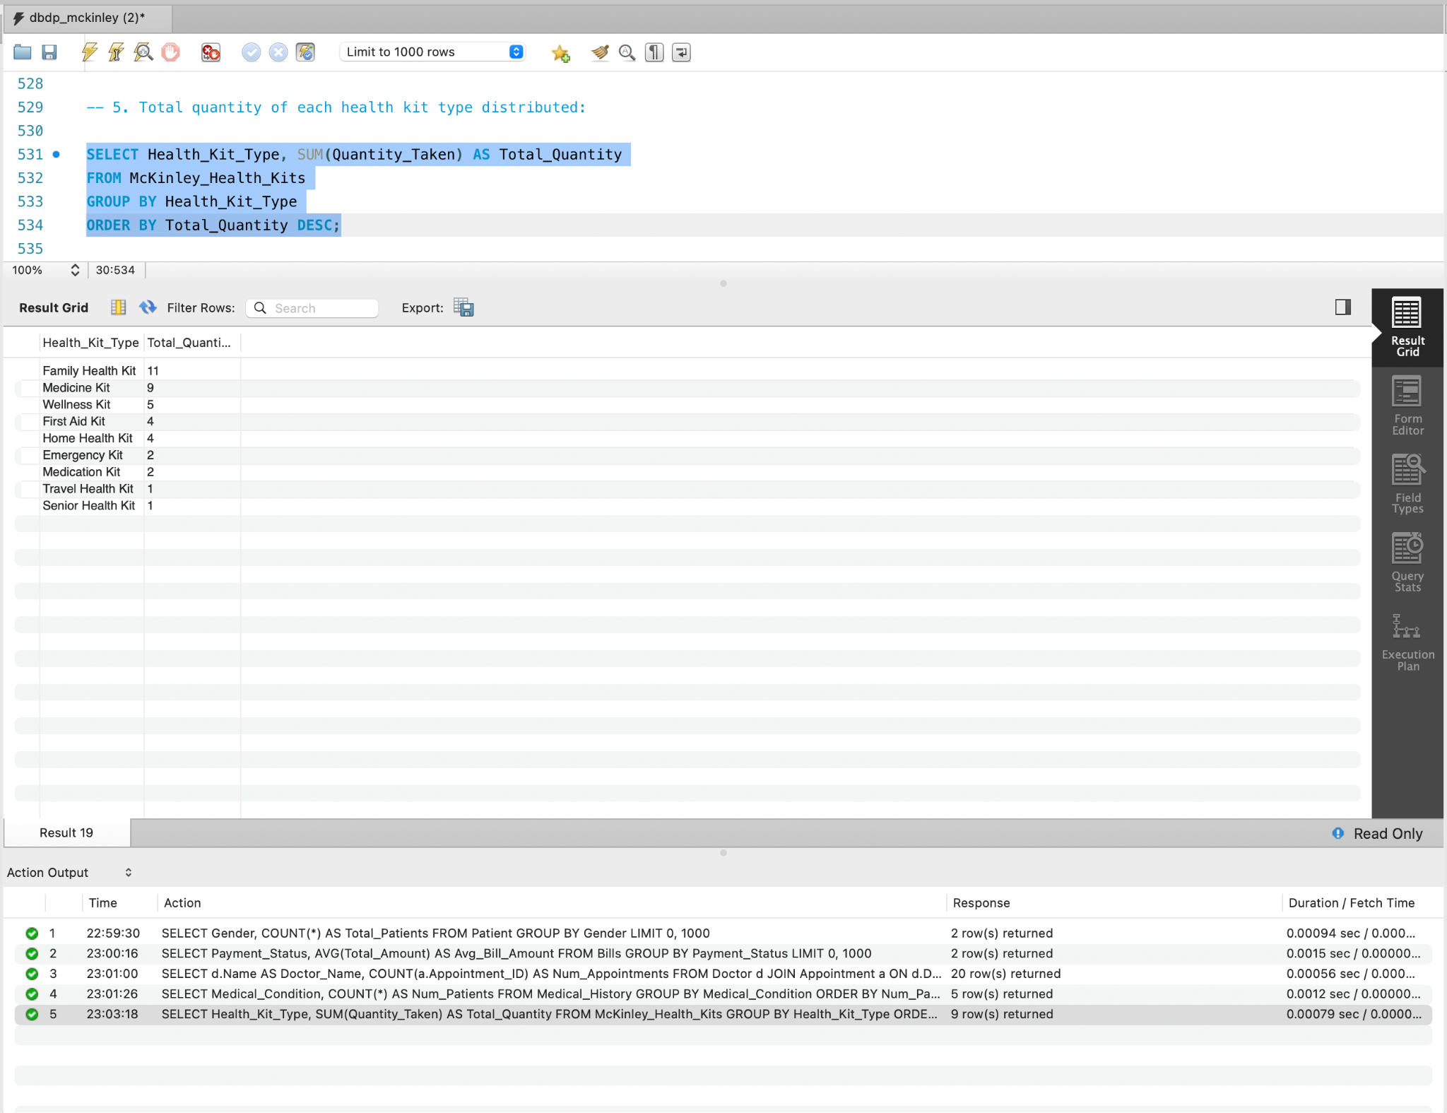

**6. Average age of patients at diagnosis:**

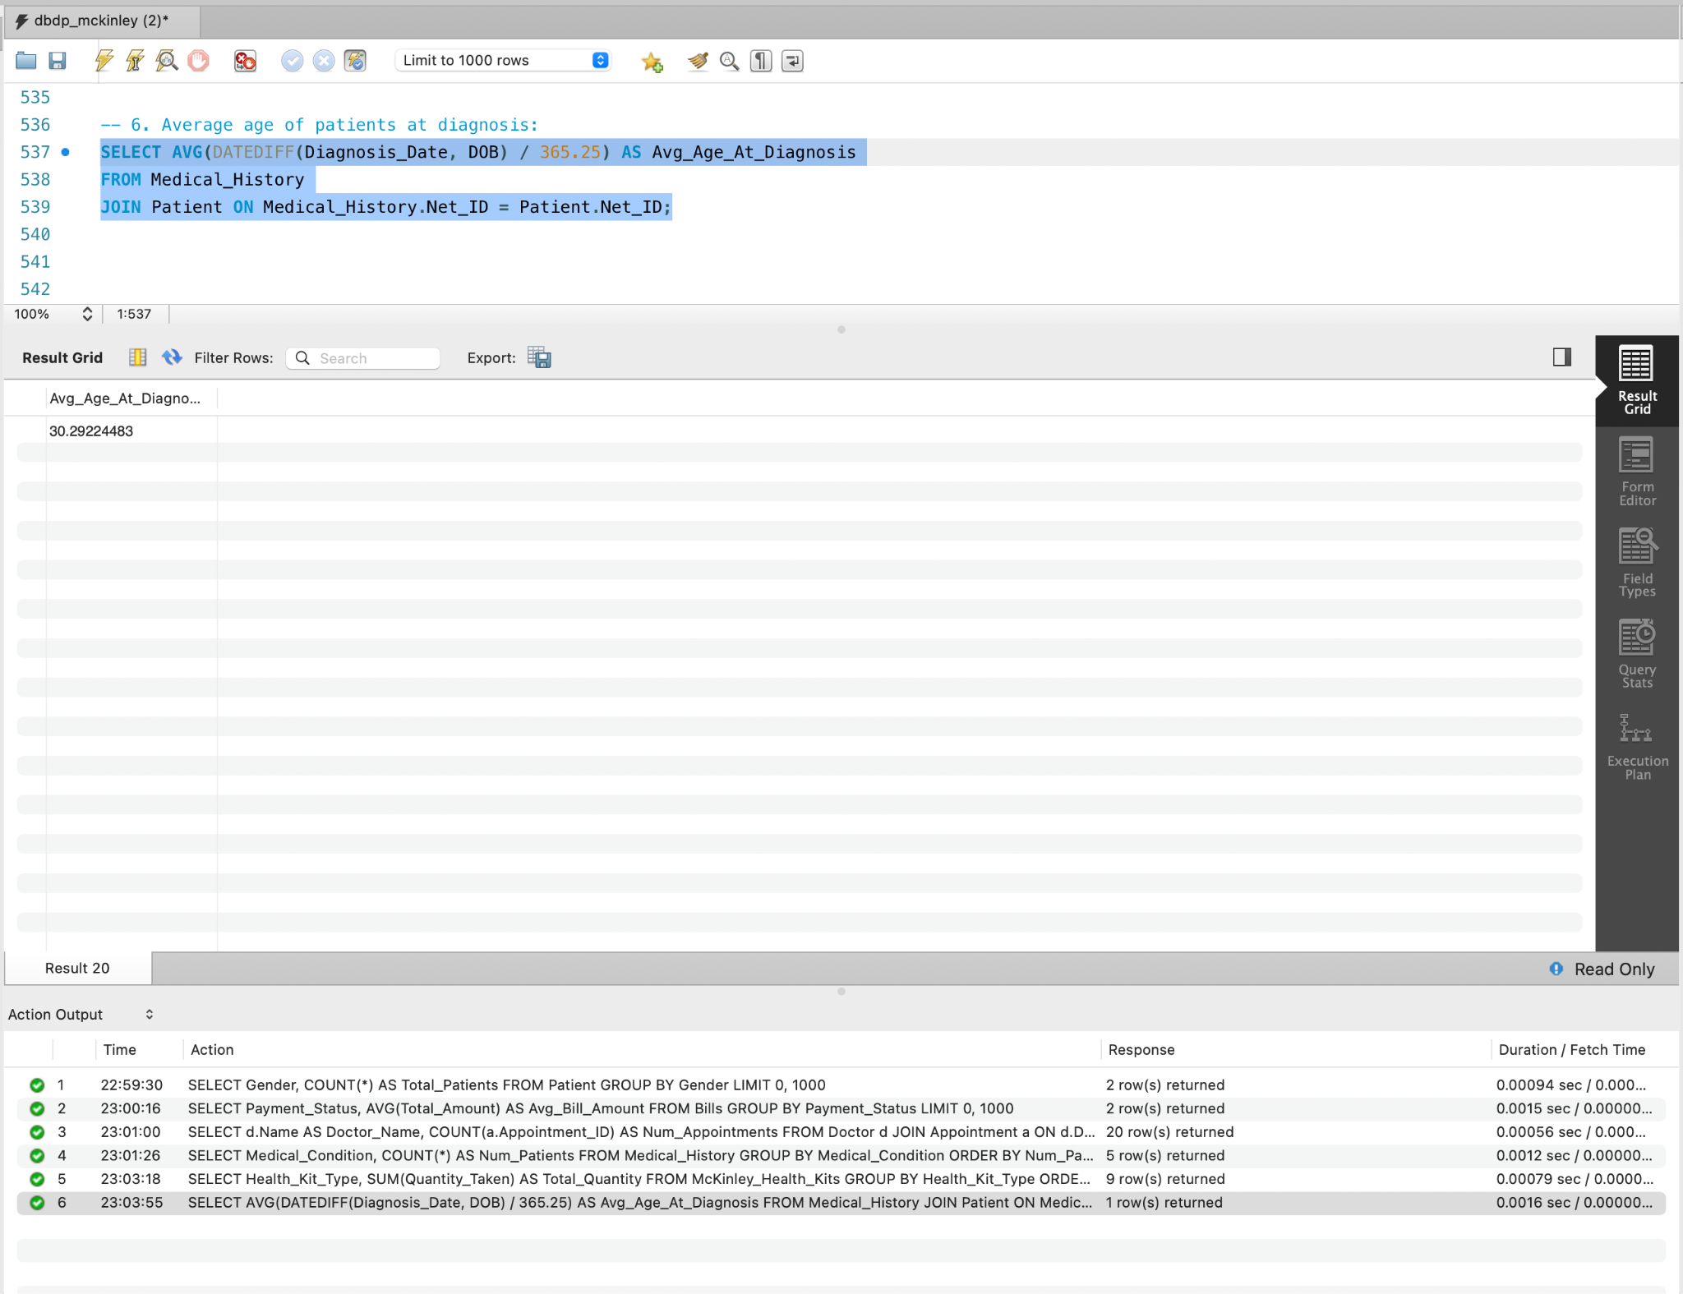

**7. Join Appointment with Doctor and Patient to get Appointment Details along with Assigned Doctor and Patient's Name:**

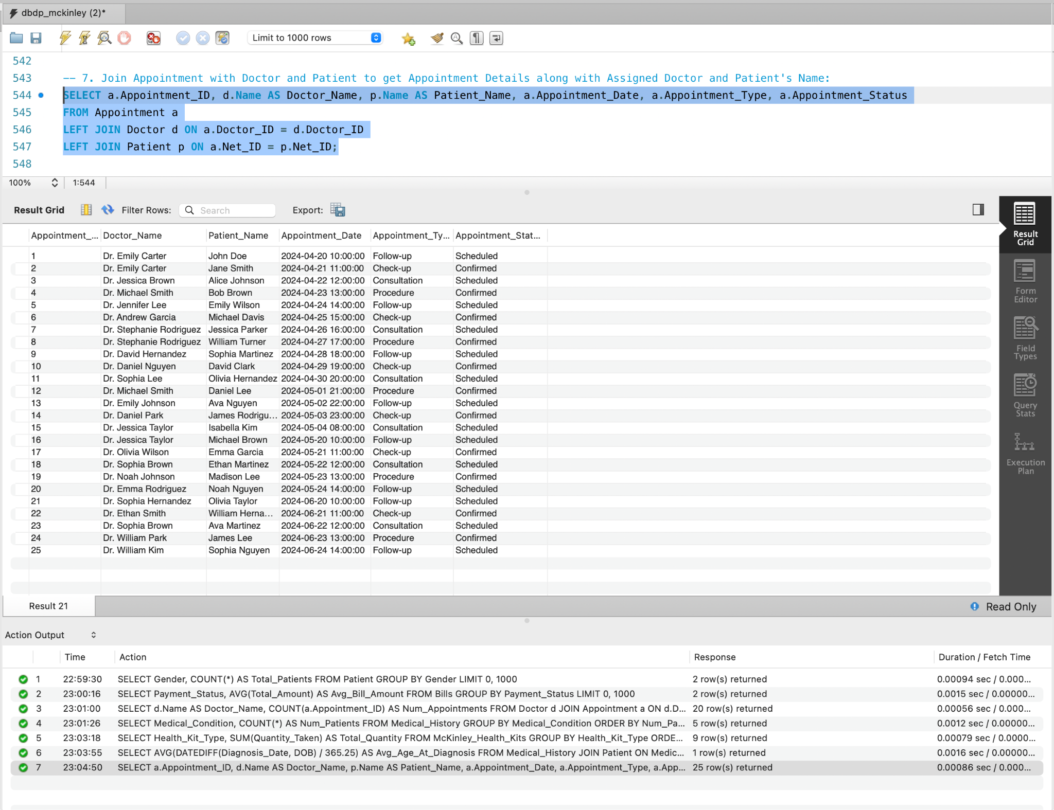

**8. Join Patient with Medical History and Lab Screening to get Patient's Details along with their Medical History and Lab Test Results:**

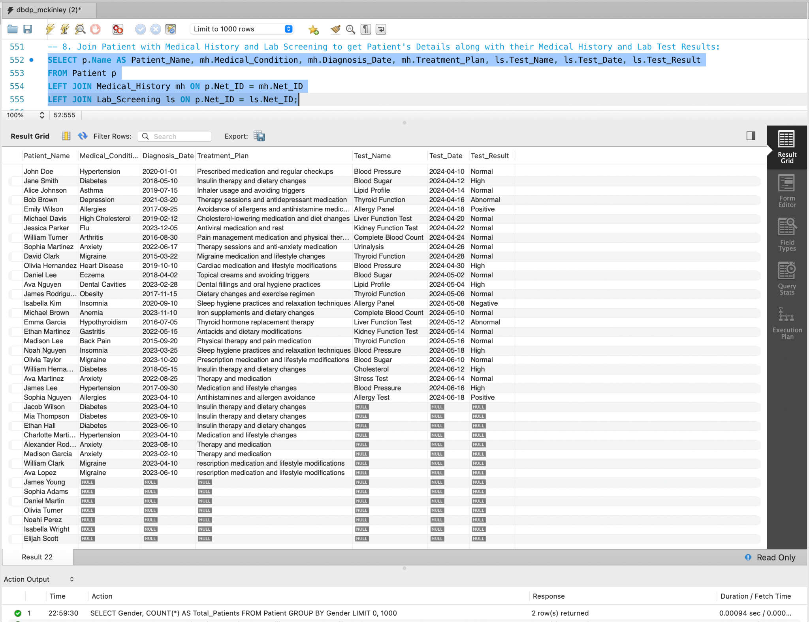

**9. Patient Count and Average Bill Amount by Insurance Provider:**

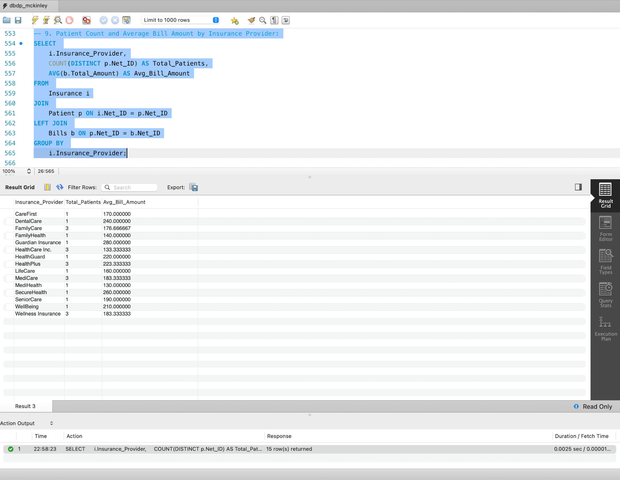

**10. Revenue Generated by Each Department:**

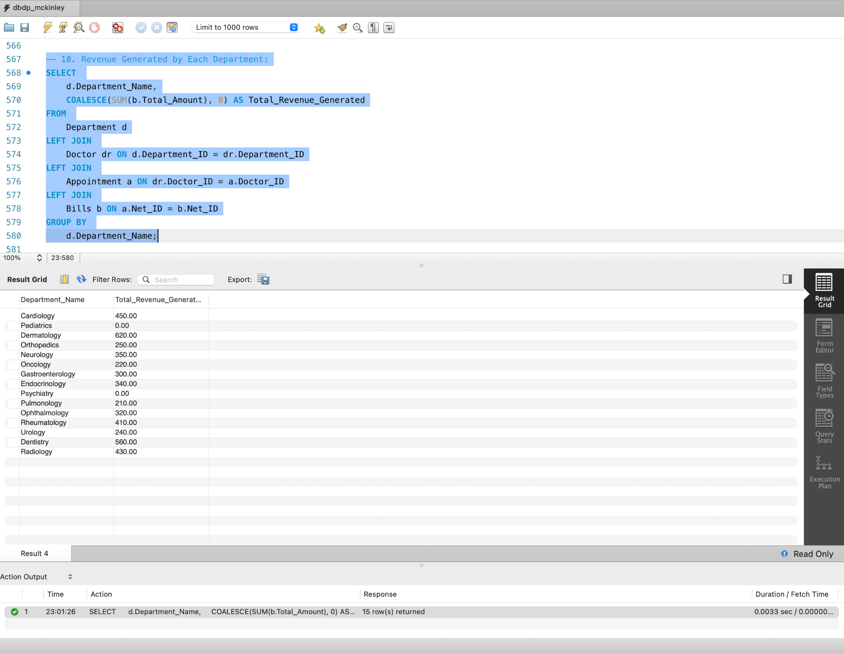

**11. Busiest departments based on appointment counts**

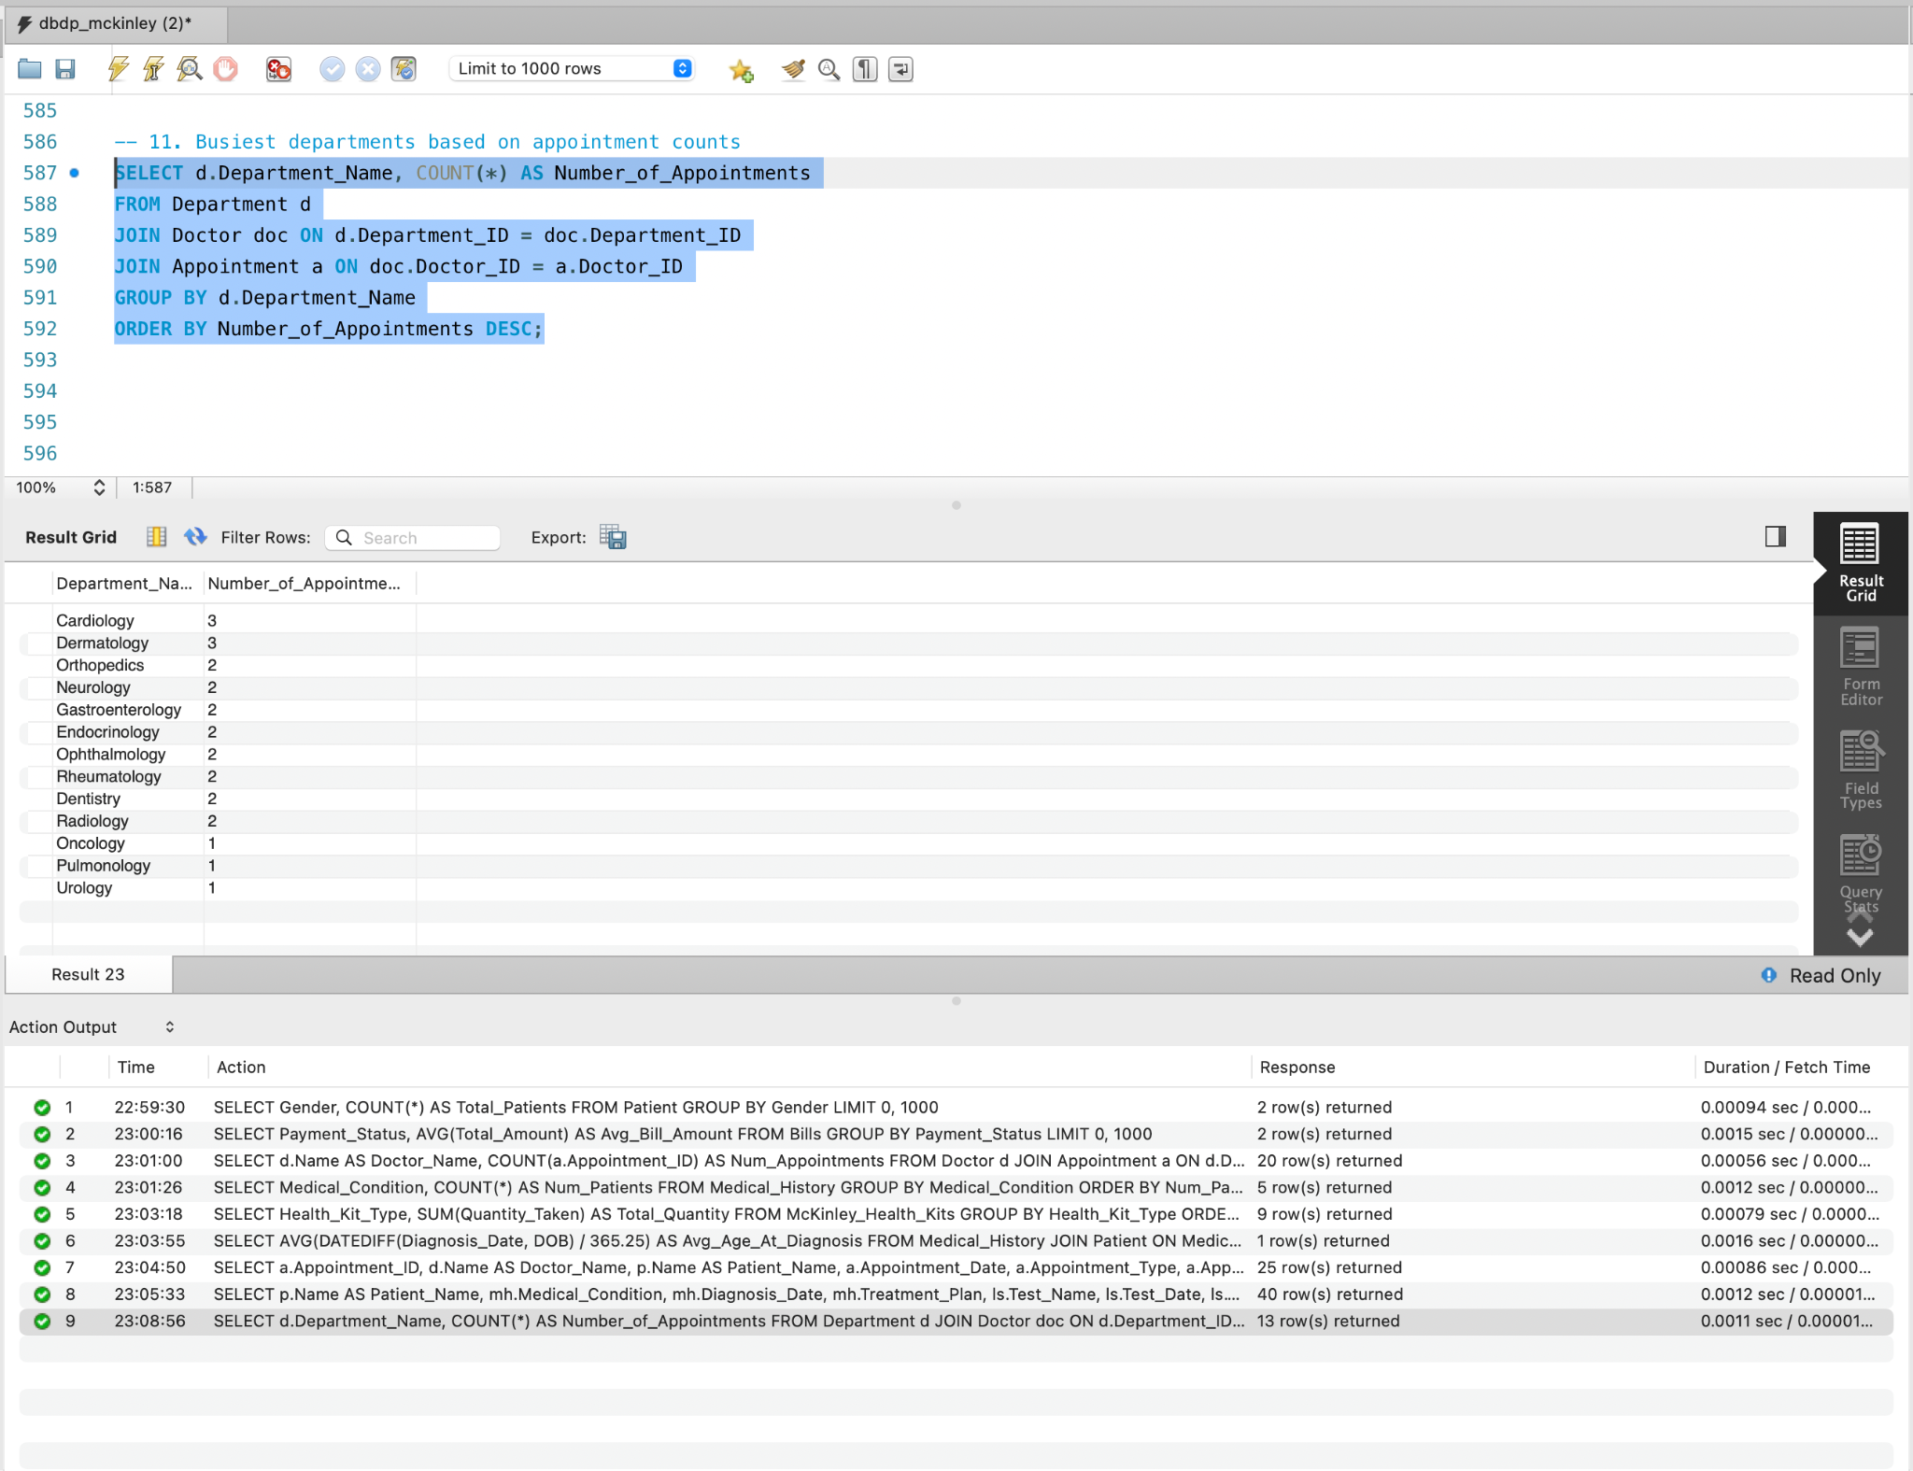

**12. Modification - UPDATE**

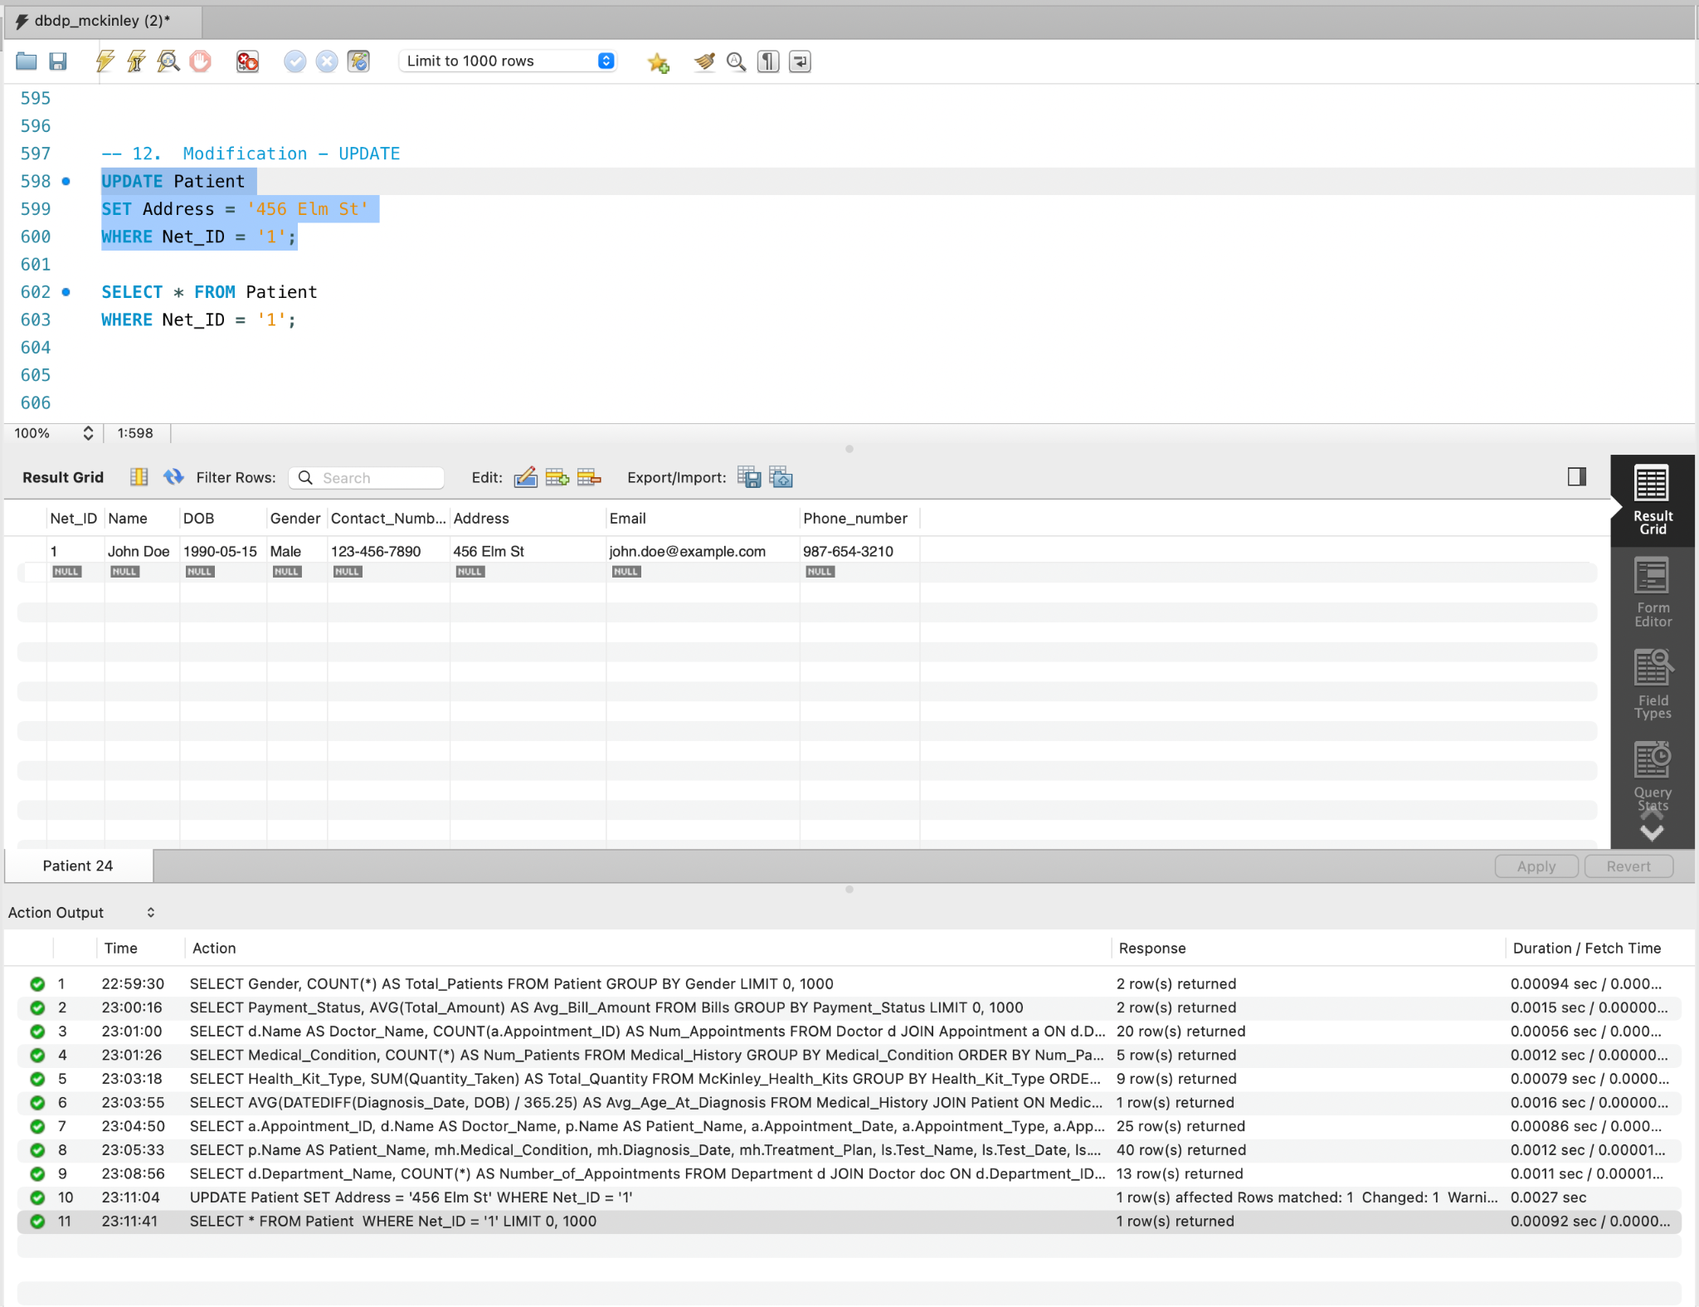

**13. Categorize Patients by Age group**

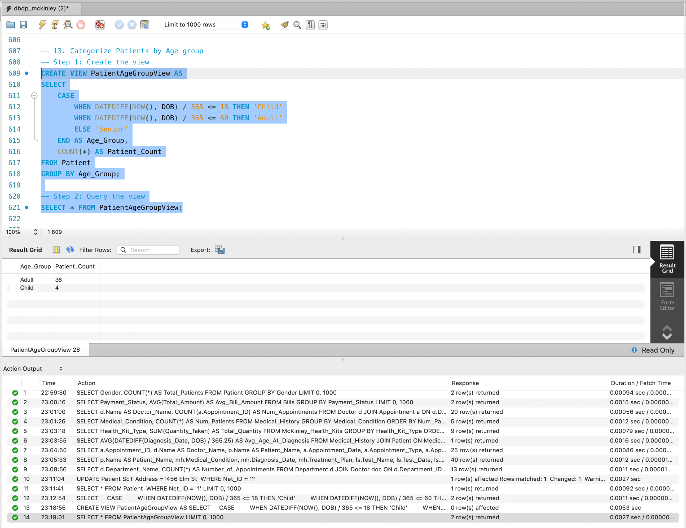

**14. Before Dropping Nurse Table:**

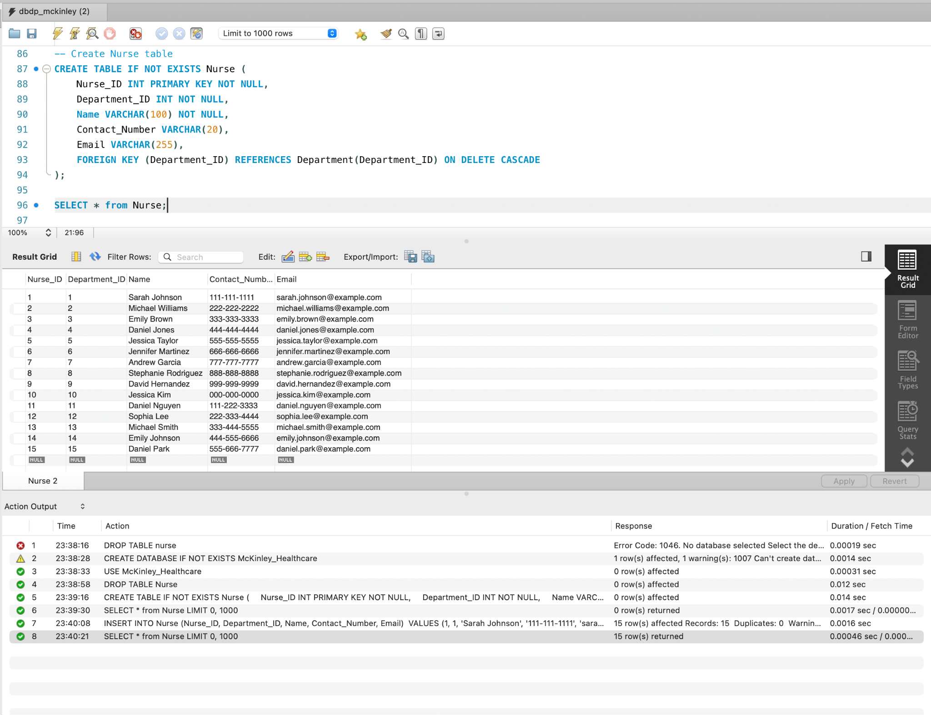

**After dropping Nurse Table:**

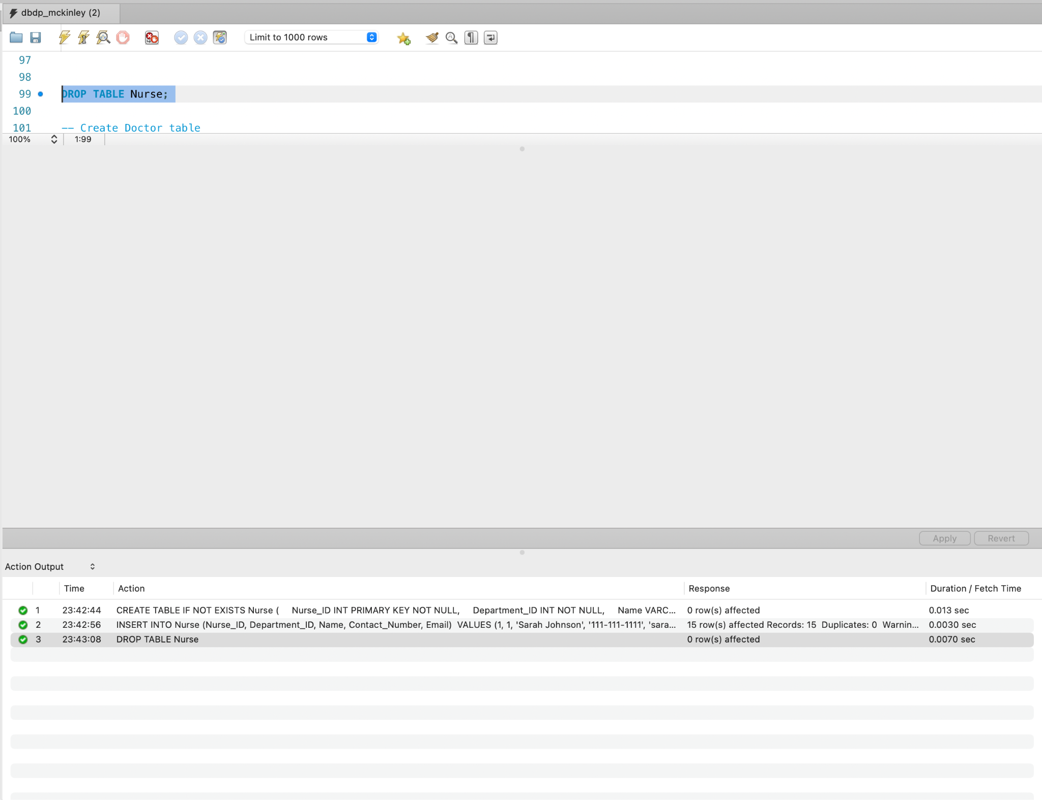

**VIII. Security Access Management**

In database management systems (DBMS), Security Access Control is the practice of regulating access to database data exclusively to authorized individuals. It encompasses a framework of regulations or guidelines dictating how data is accessed, utilized, and administered by various user entities or user groups.

The primary objective of Security Access Control is to safeguard sensitive and confidential data from unauthorized access, alteration, or destruction. Through access control mechanisms, databases can bar unauthorized users from accessing or modifying data, while ensuring that users only access the data necessary for their assigned tasks.

Within DBMS, there exist several Access Control Models, including Discretionary Access Control (DAC), Mandatory Access Control (MAC), Role-Based Access Control (RBAC), and Attribute-Based Access Control (ABAC). Each model operates under its unique set of regulations and policies to manage data access. These models can be implemented at different levels, such as system-wide, database-wide, or object-specific levels.

In our project, we exemplified Security Access Control using the Role-Based Access Control (RBAC) model. For a more detailed understanding, please refer to the attached screenshots below.

We created a user called Doctor which has access to select , insert , update , delete and alter on Patient , Appointment , prescription , medical_history and lab_screening to the user.  
  
We created a user called Nurse which has access to select , insert , update , delete and alter on Patient , Appointment , prescription , medical_history and lab_screening to the user.

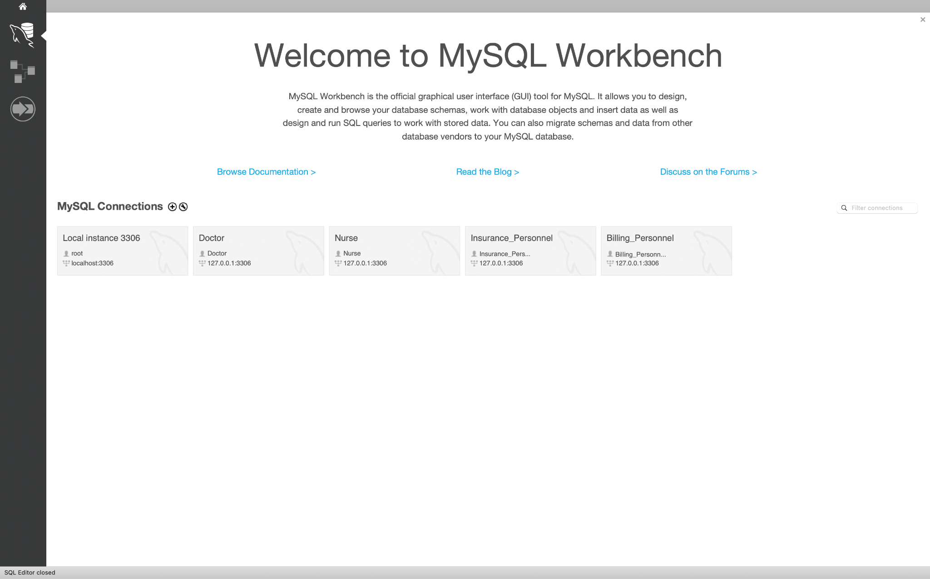

Doctor

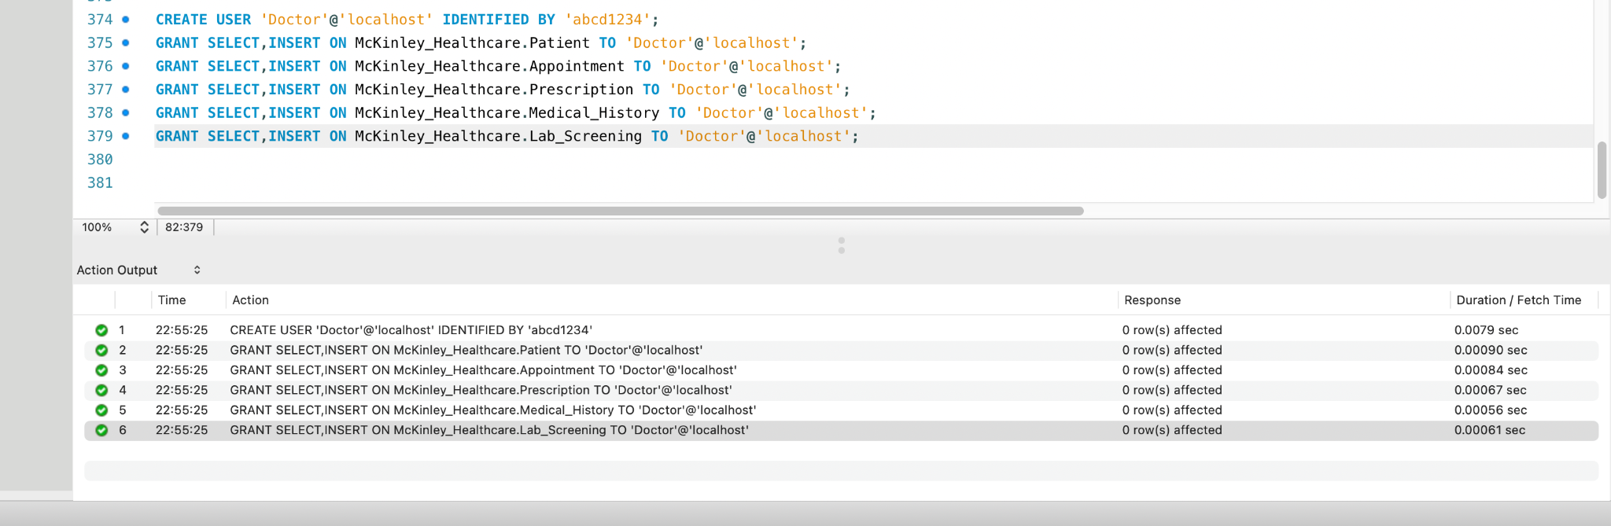

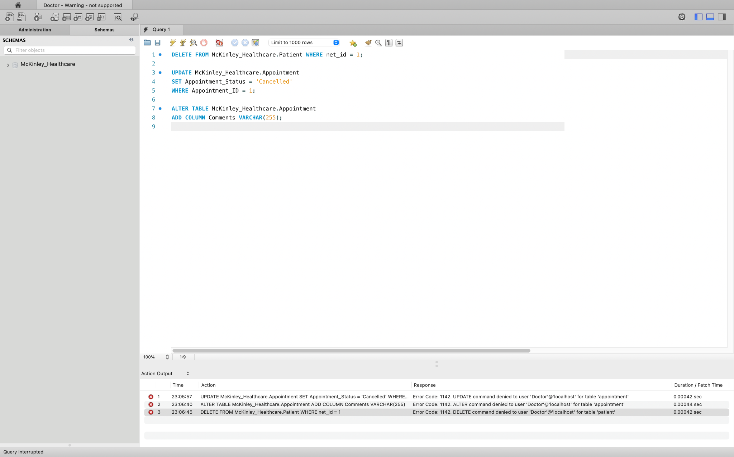

Nurse

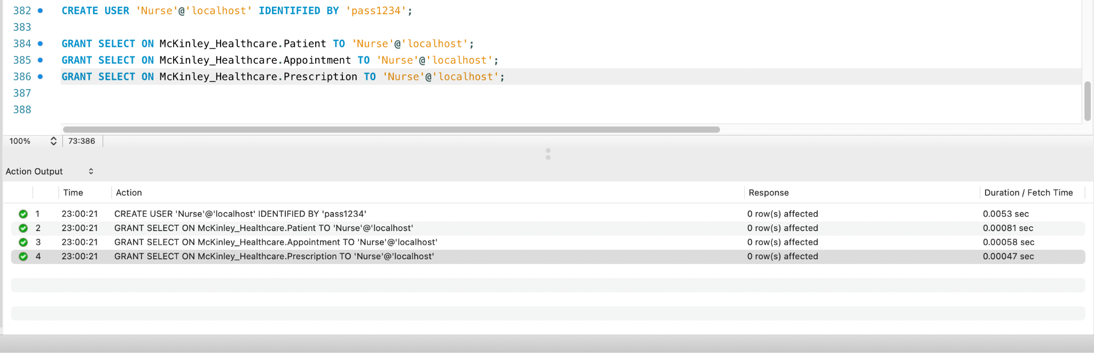

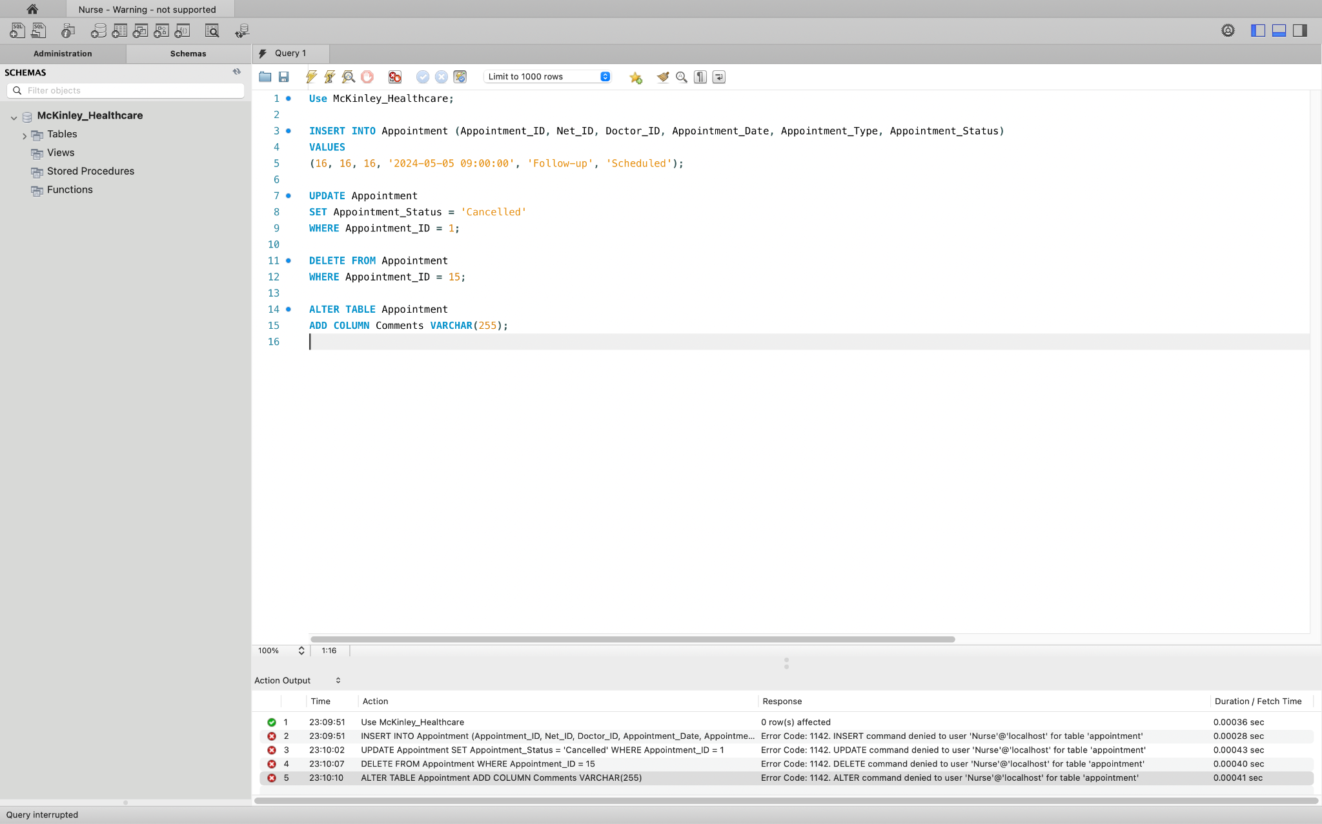

Insurance_Personnel

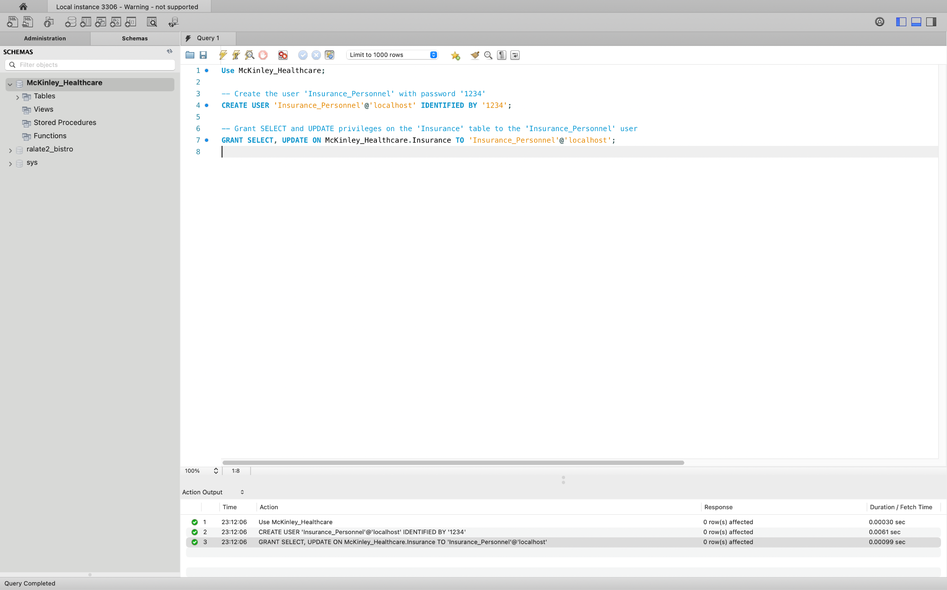

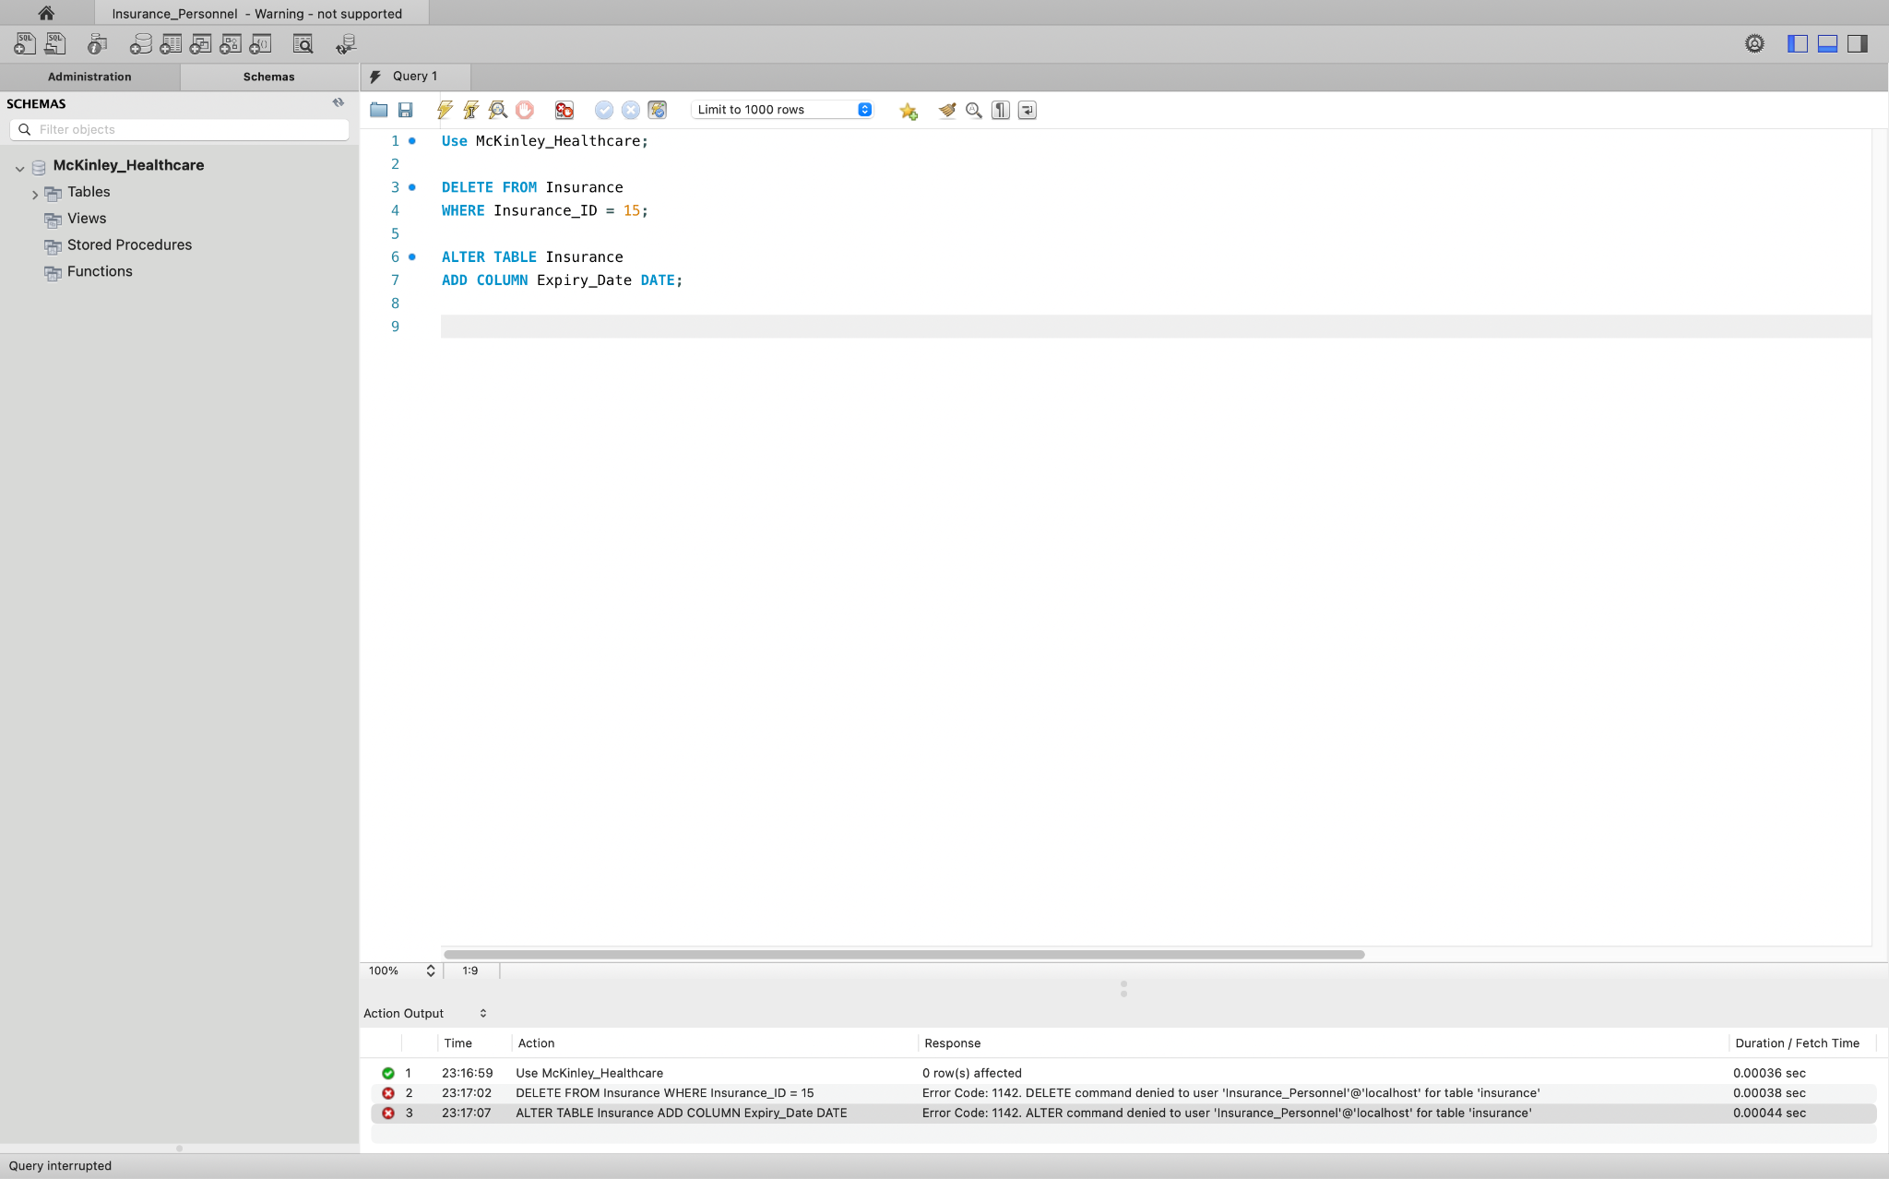

Billing_Personnel

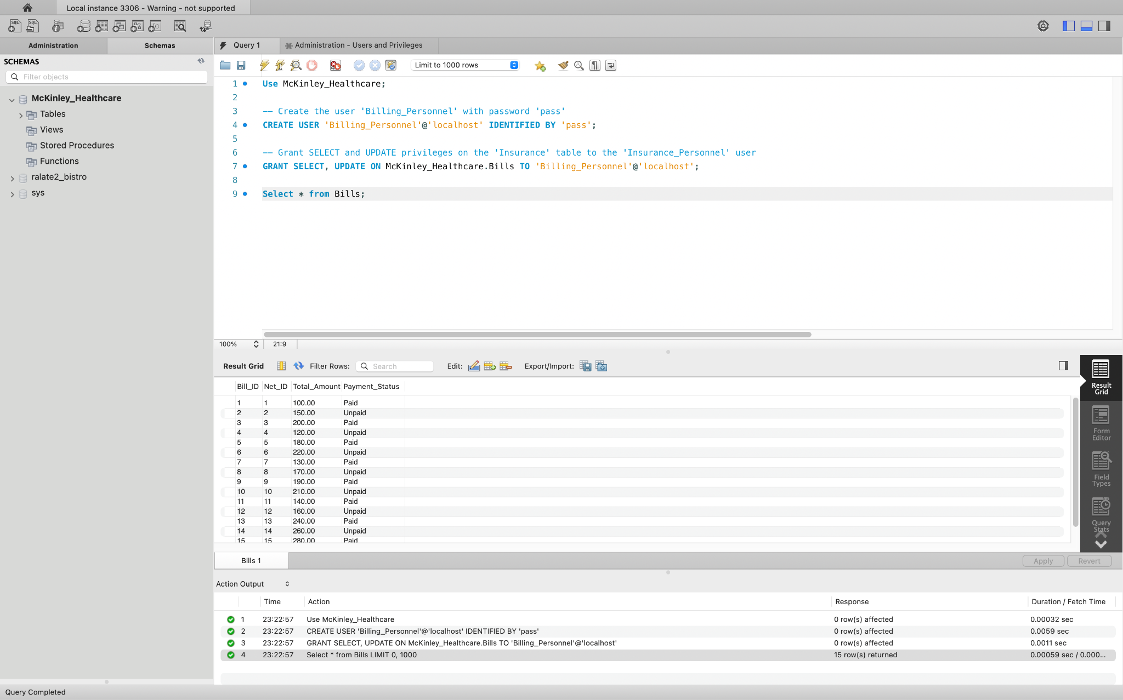

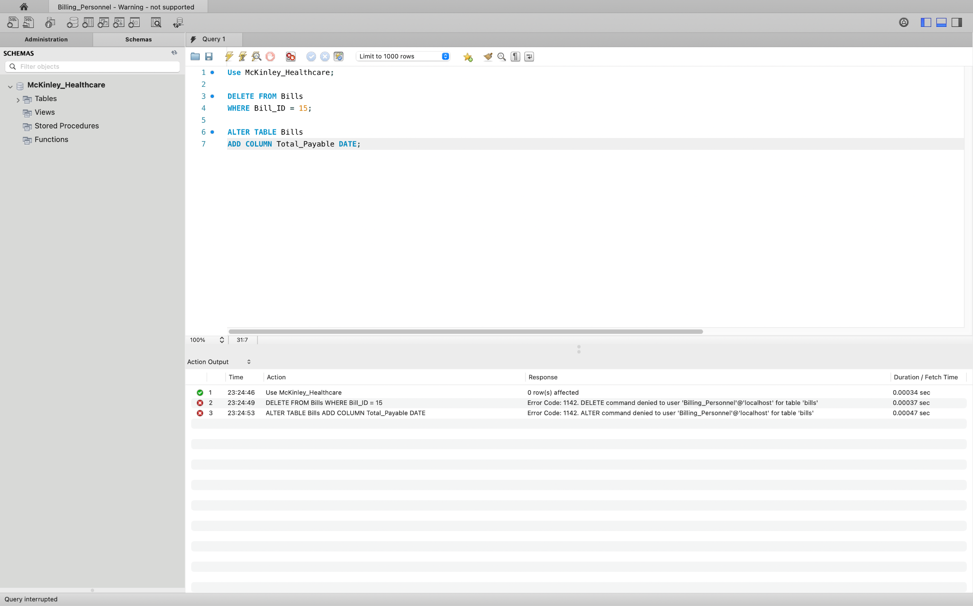

**VIII. BACKUP AND RESTORE:**

**1. Backup Procedure:**

We initiated the backup process for the `McKinley_Healthcare` database using the `mysqldump` command:

***mysqldump -u root -p McKinley_Healthcare > backup_file.sql***



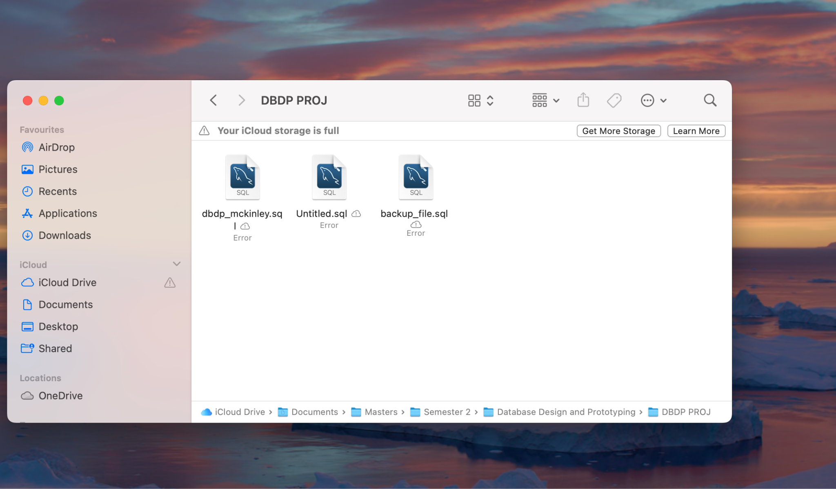

This command exported the SQL statements required to recreate the structure and data of the `McKinley_Healthcare` database into a file named `backup_file.sql`.

Upon executing the command, we were prompted to enter the password for the MySQL root user.

**2. Database Creation:**

Following the backup, we proceeded to create a new database named `Backup_McKinley_Healthcare` using the MySQL command-line interface:

***CREATE DATABASE Backup_McKinley_Healthcare;***

This command successfully created a new database with the specified name.

**3. Database Restoration:**

Next, we restored the backed-up data from `backup_file.sql` into the newly created `Backup_McKinley_Healthcare` database:

***mysql -u root -p Backup_McKinley_Healthcare < backup_file.sql***

This command imported the SQL statements from the backup file into the specified database. Upon execution of the command, we were prompted to enter the password for the MySQL root user once again.

**4. Verification:**

To ensure the successful restoration of the data, we logged into the MySQL command-line interface. We verified the existence of the newly created database by listing all databases using the command:

***show databases;***

The list included the `Backup_McKinley_Healthcare` database among others. Subsequently, we switched to the `Backup_McKinley_Healthcare` database using the command:

***use Backup_McKinley_Healthcare;***

We confirmed the presence of tables by executing the command:

***show tables;***

Finally, to validate the data restoration, we queried all records from the `Patient` table using the command:

***select * from Patient;***

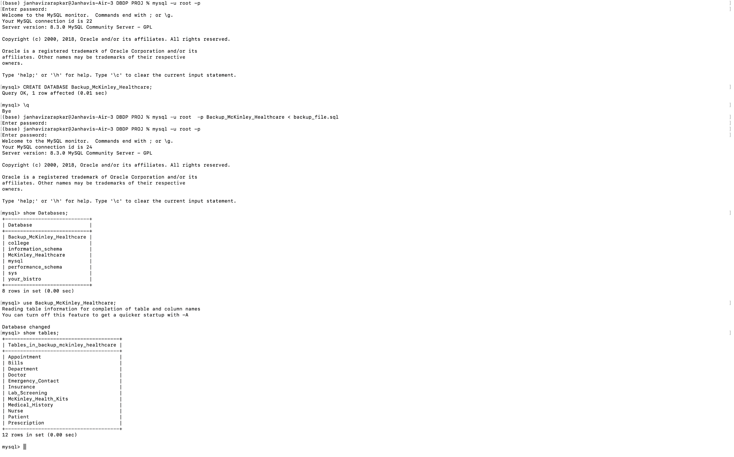

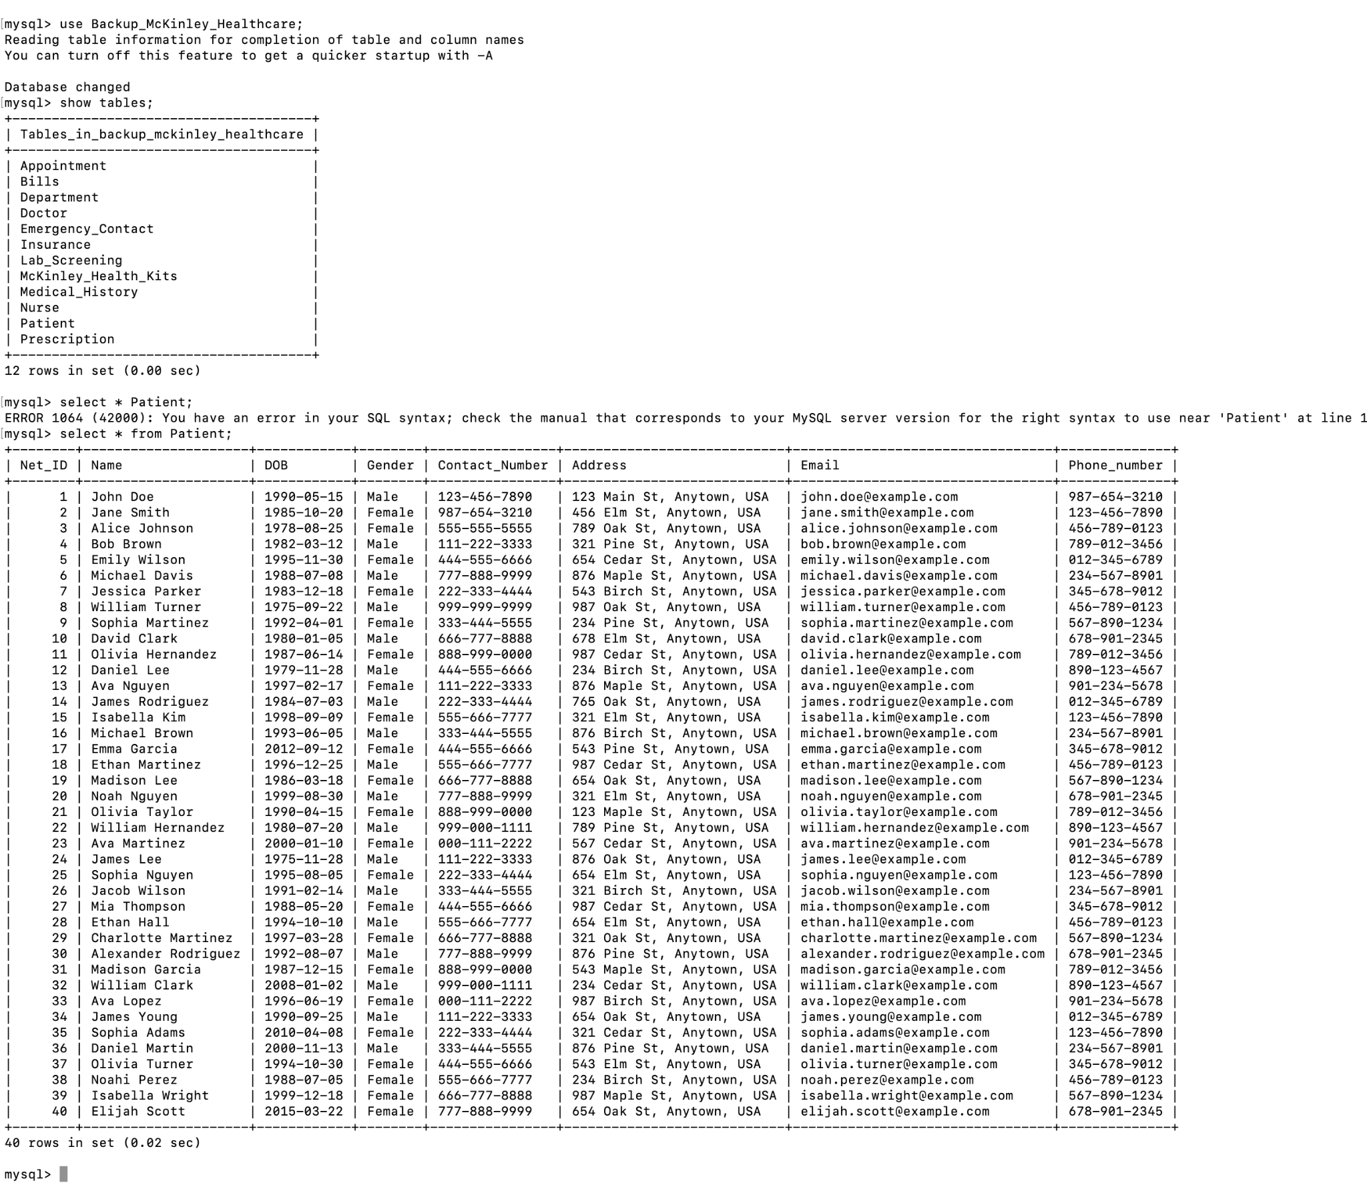

This comprehensive process ensured the successful backup and restoration of the `McKinley_Healthcare` database into the newly created `Backup_McKinley_Healthcare` database.

**Benefits of Backup and Restore:**

* Data Integrity Assurance: By creating a backup database and performing restoration in a separate environment, the original data remains untouched, ensuring its integrity and preventing accidental deletion or modification. This approach allows for comprehensive validation of the restored data against the original dataset, thereby minimizing the risk of data loss or corruption during the restoration process.
* Fault-Tolerance and Recovery Readiness: Through the meticulous verification steps, including listing databases, confirming table presence, and querying records, organizations can confidently rely on the backup and restoration process as a reliable contingency plan in case of database failures or data loss events. This method ensures that critical data can be quickly recovered with minimal disruption to operations, bolstering the organization's resilience against unforeseen incidents and maintaining continuity of services.